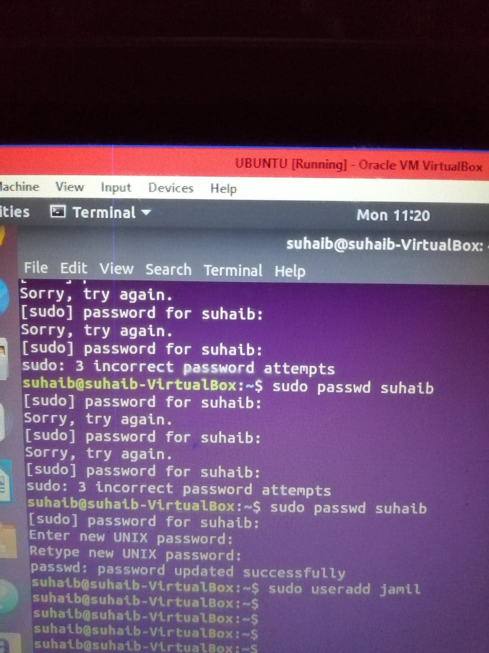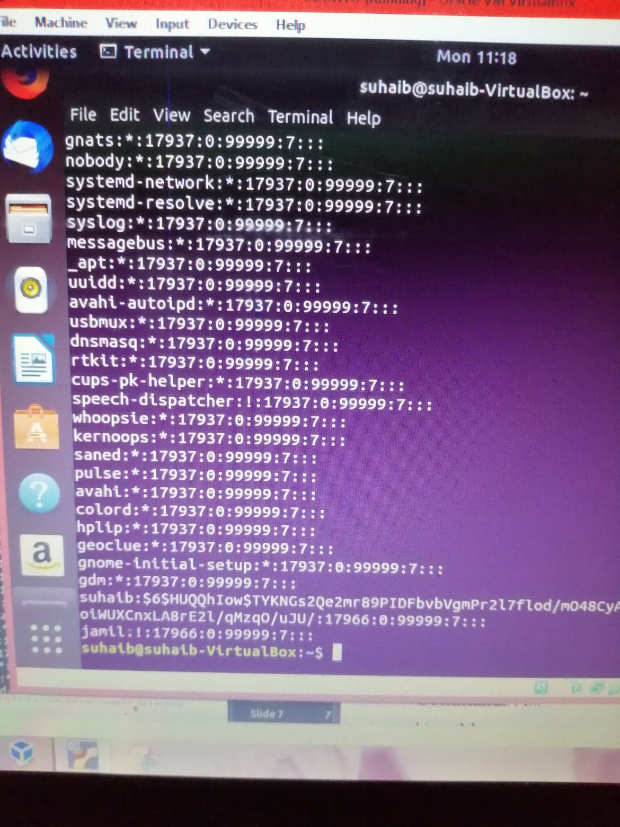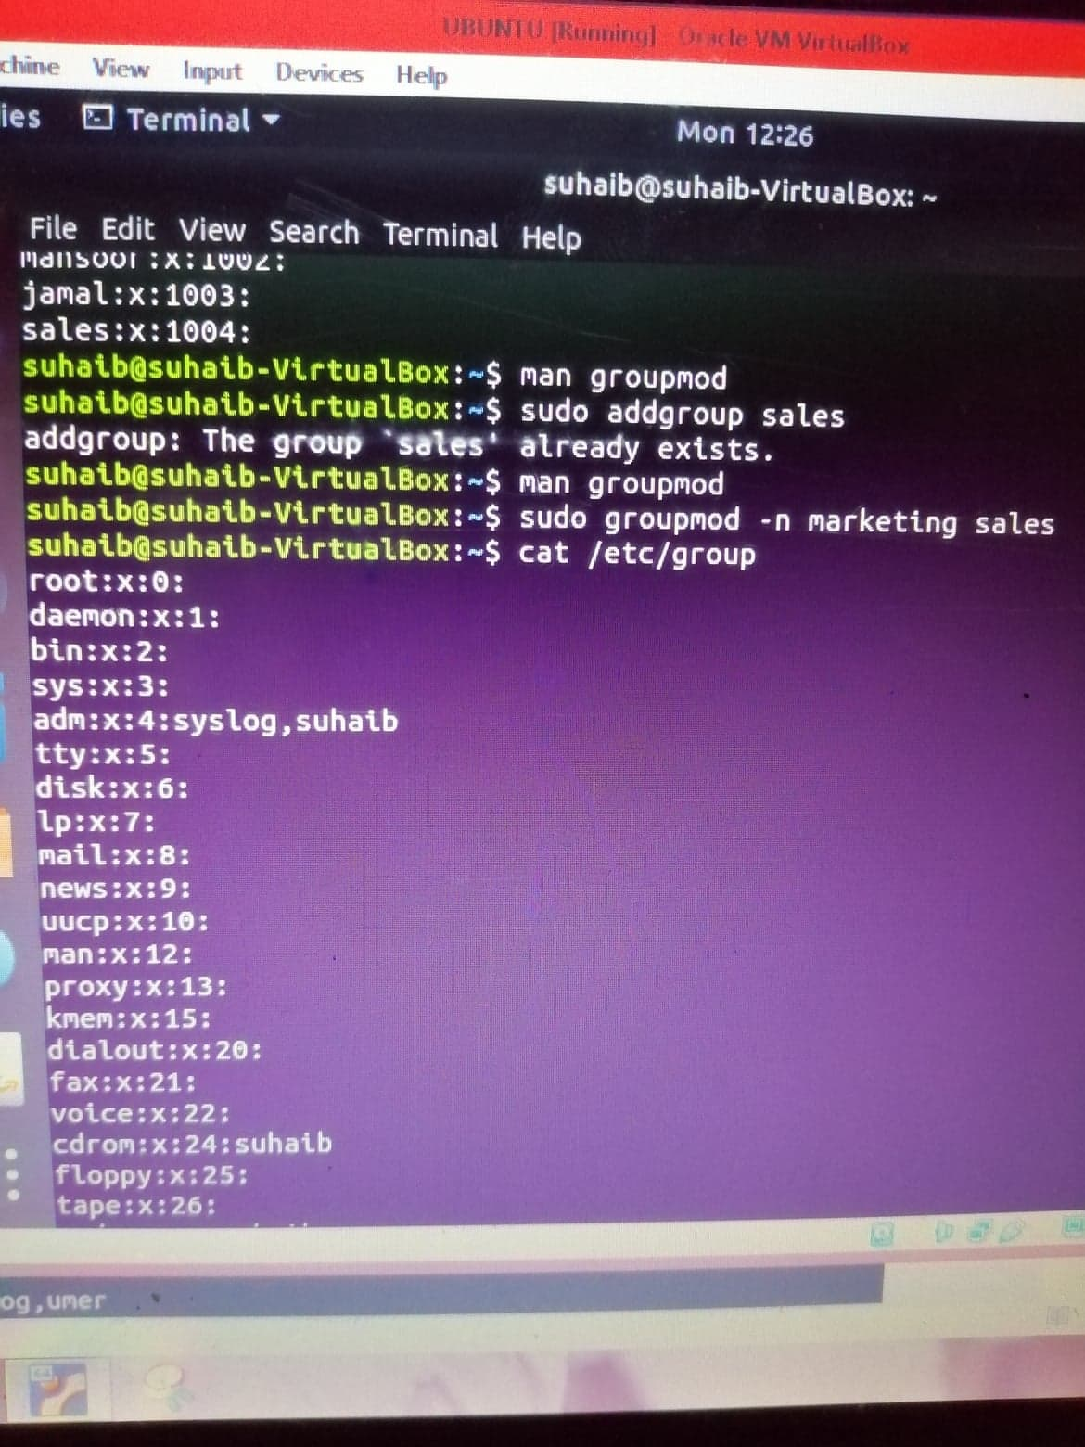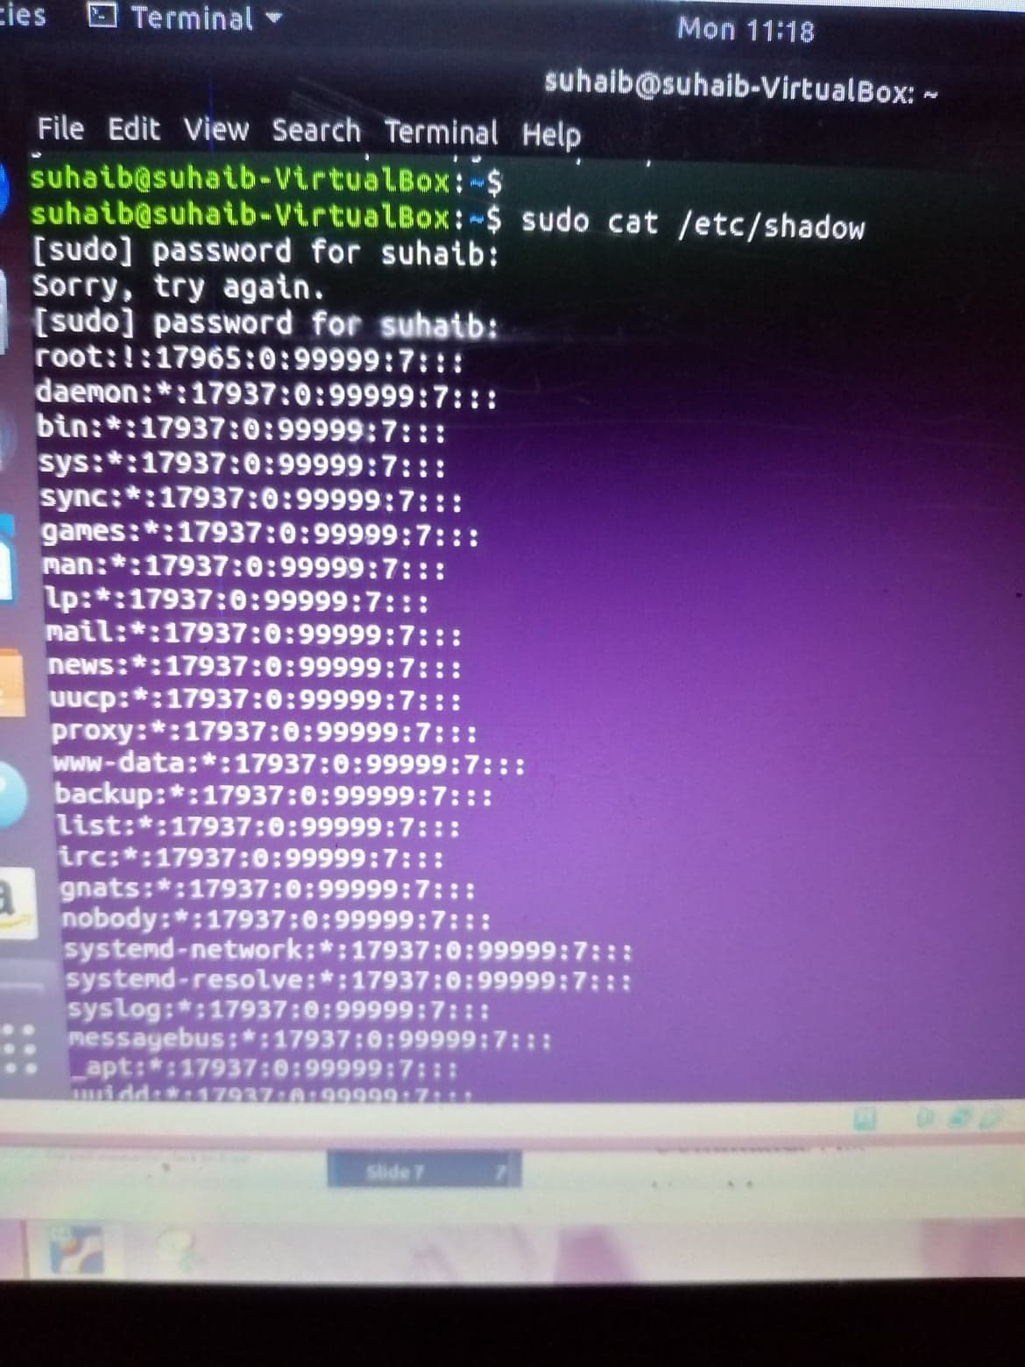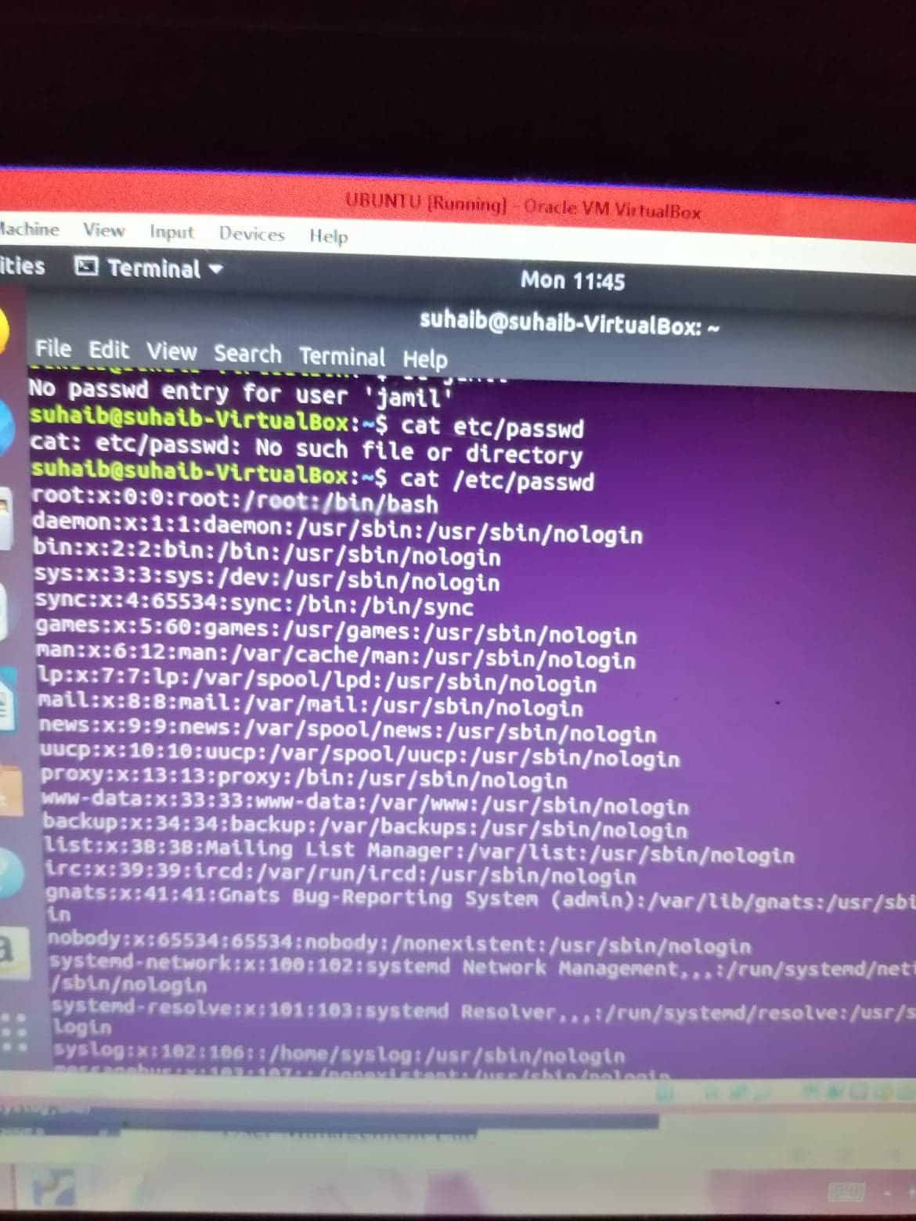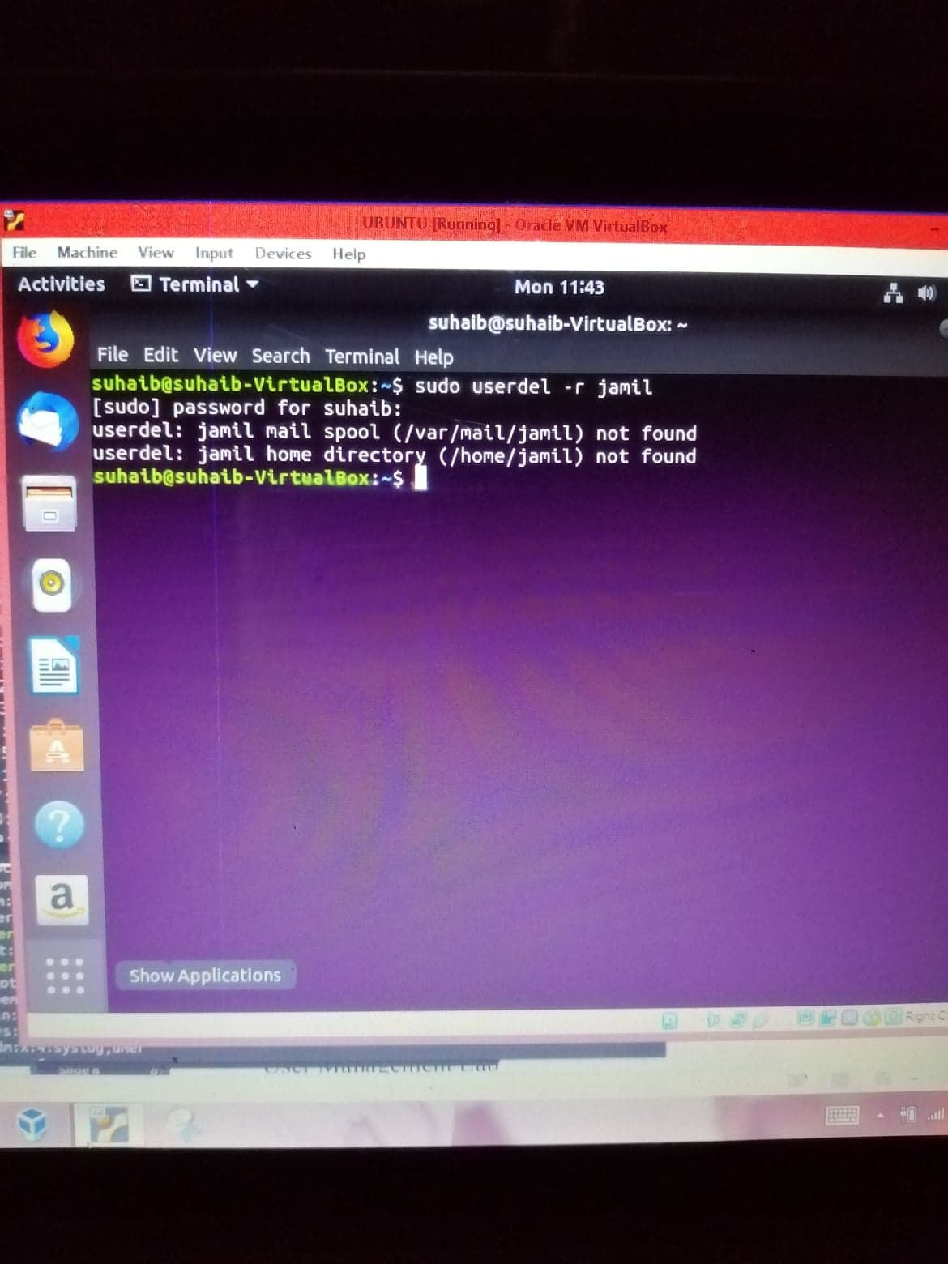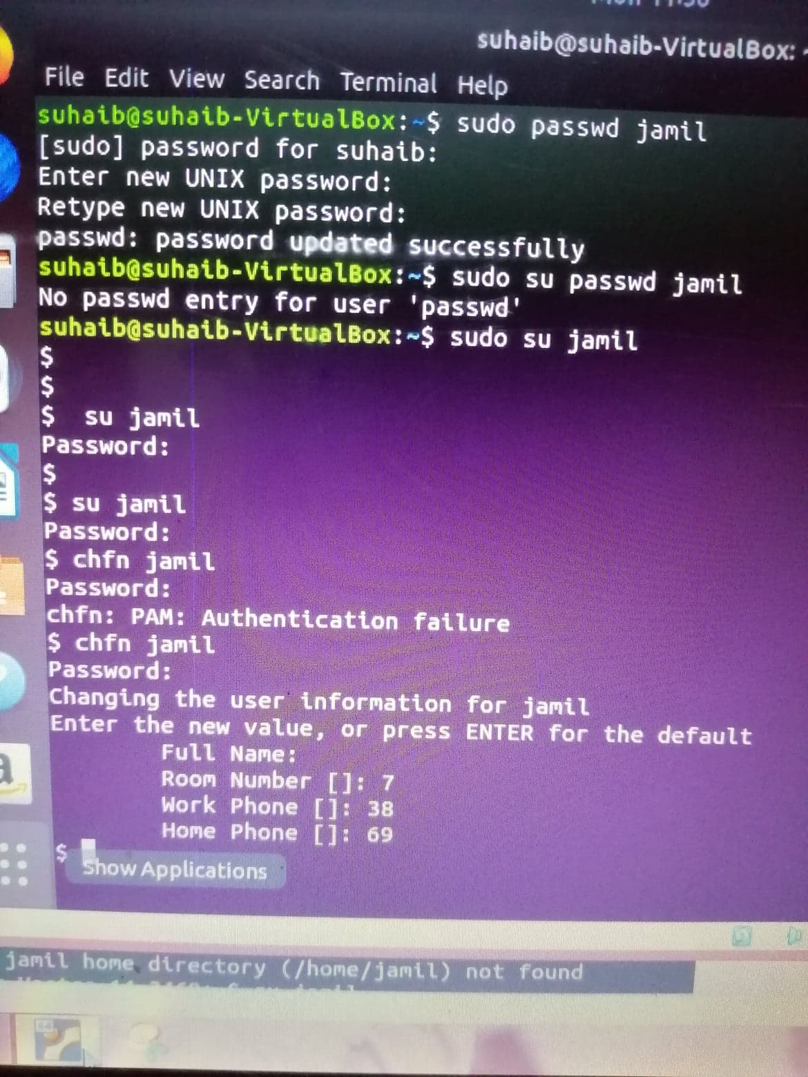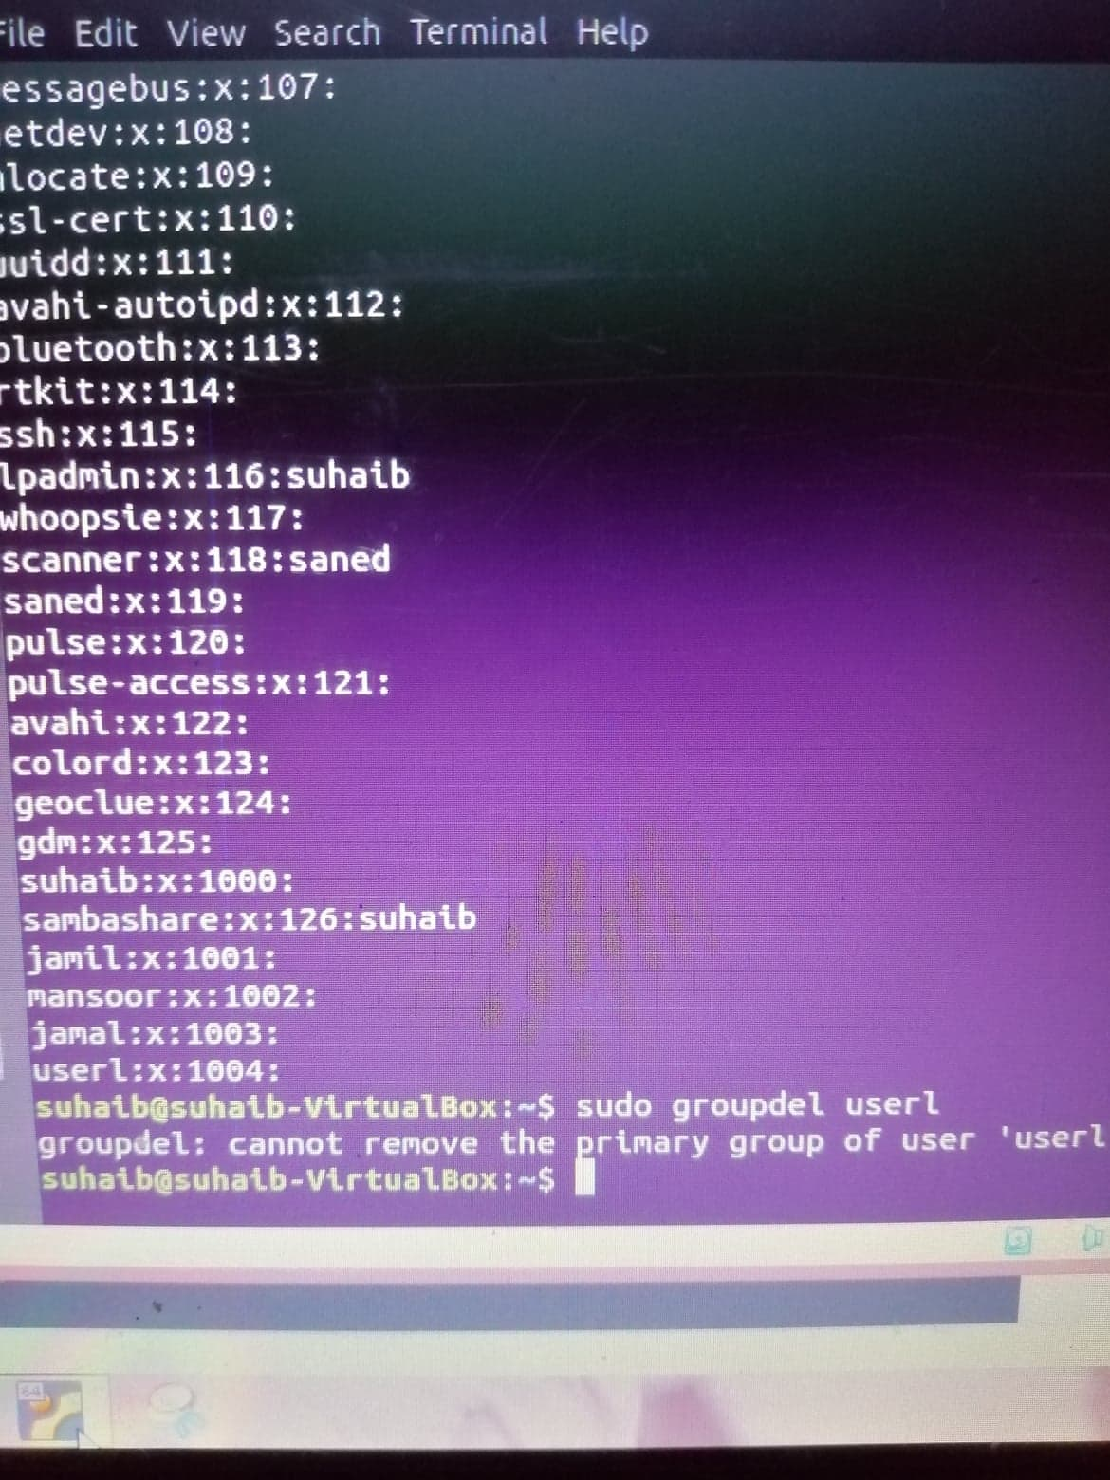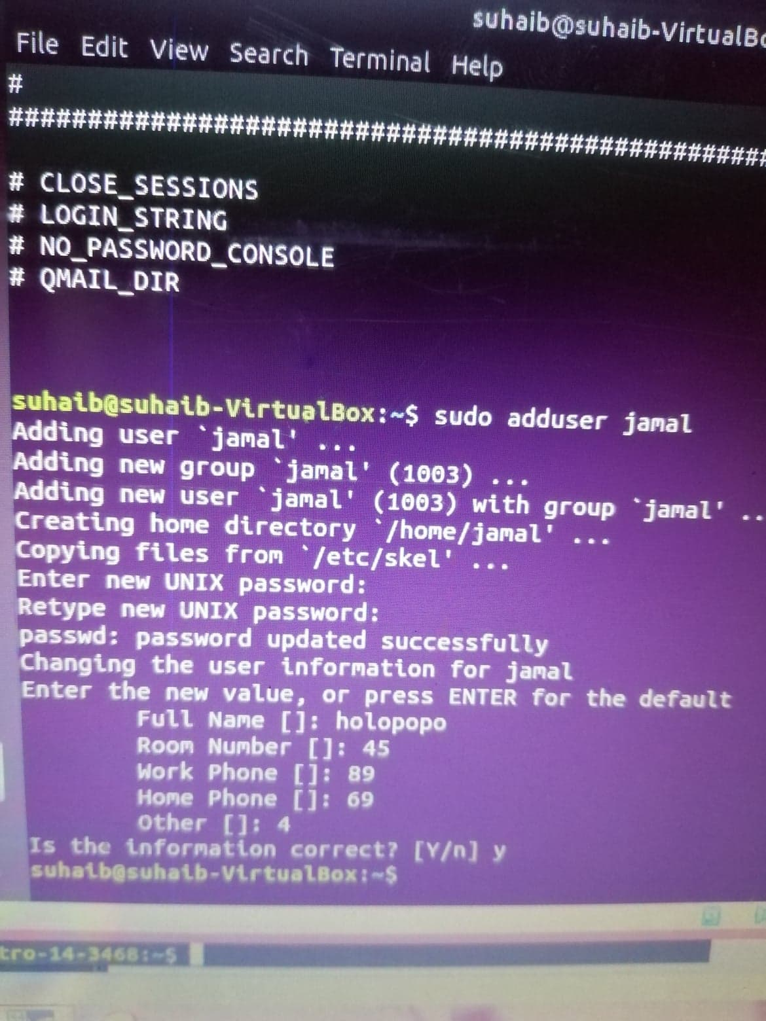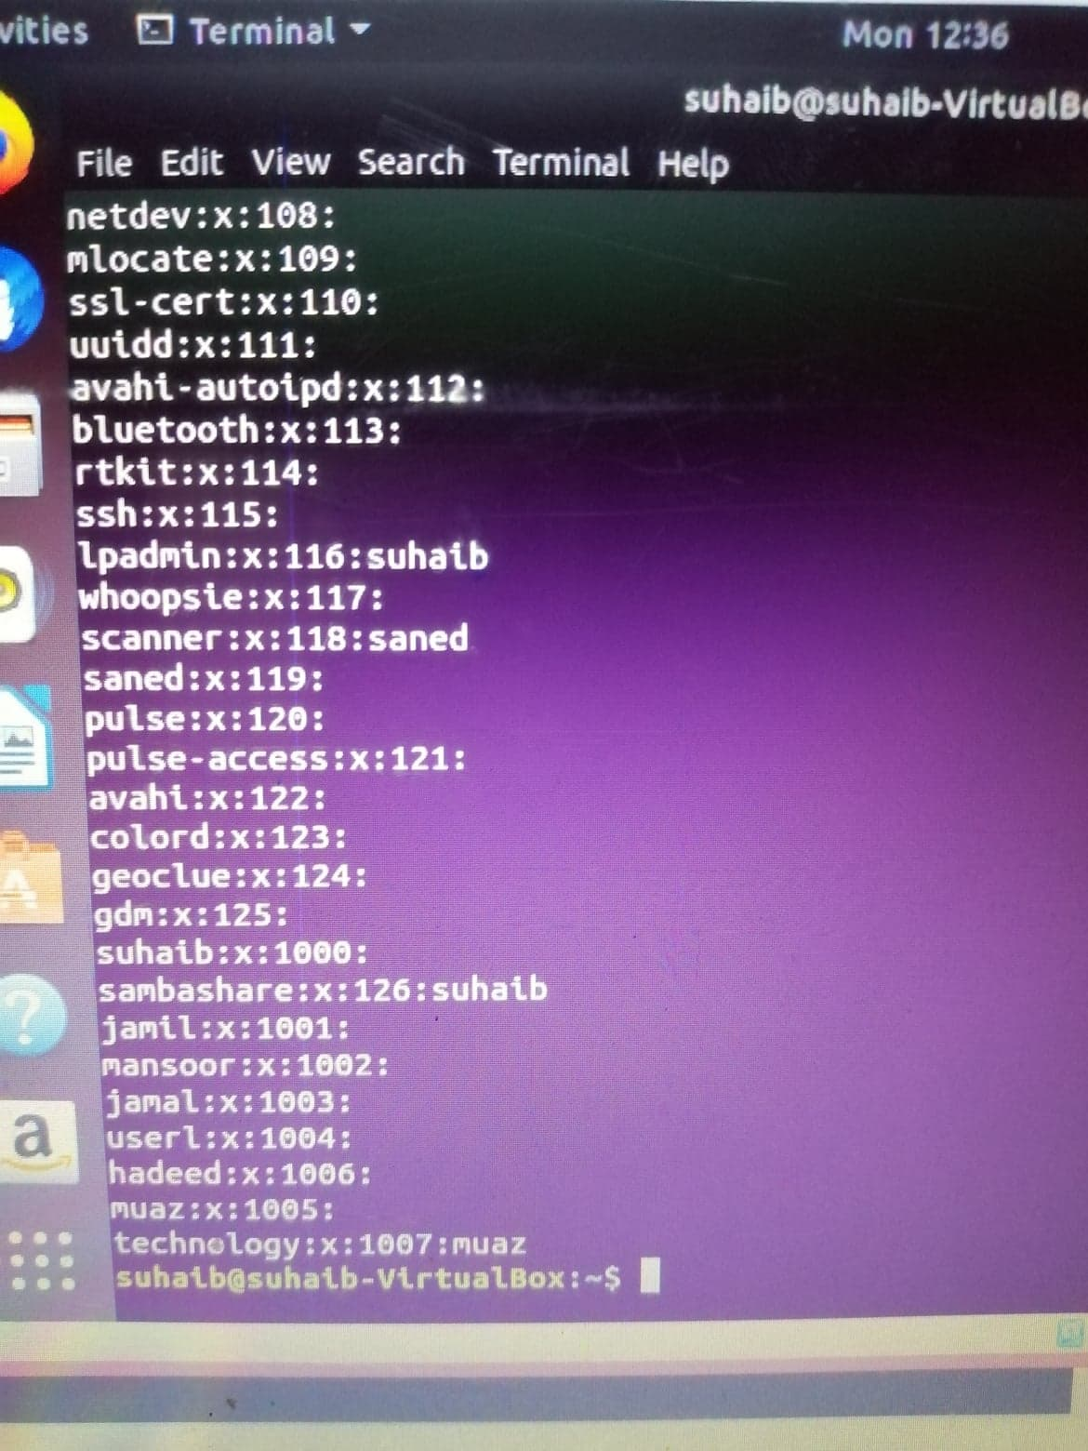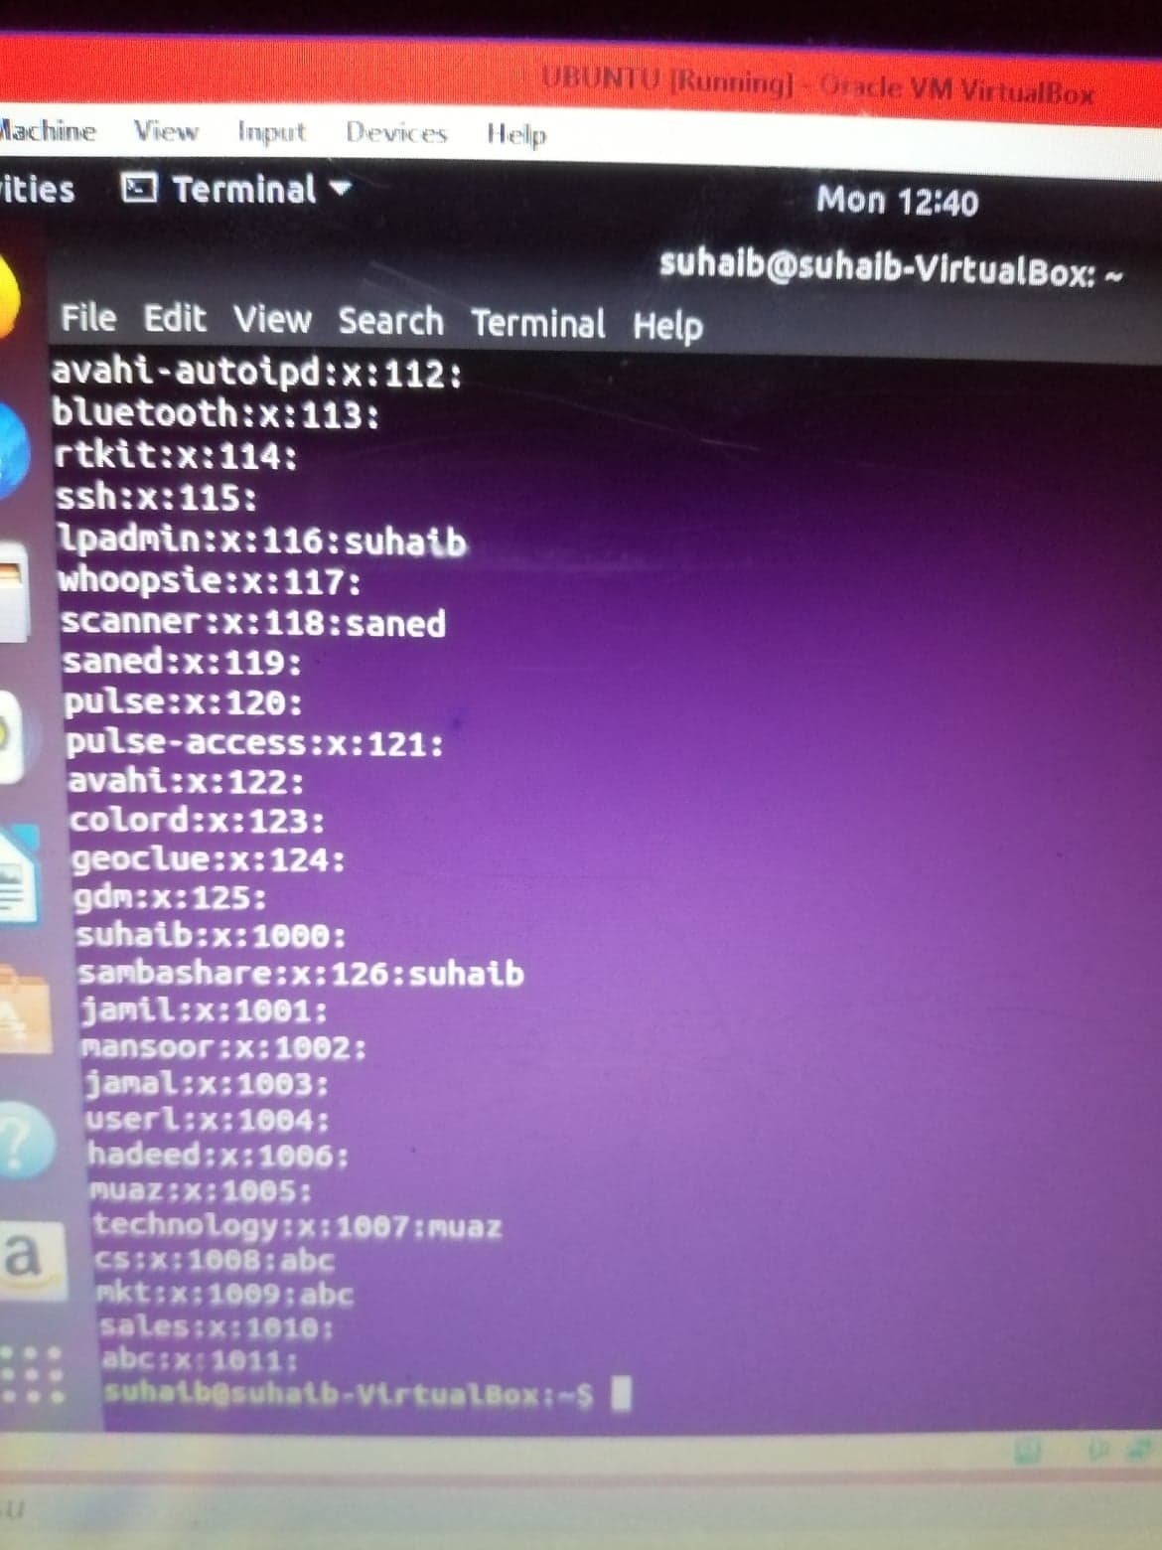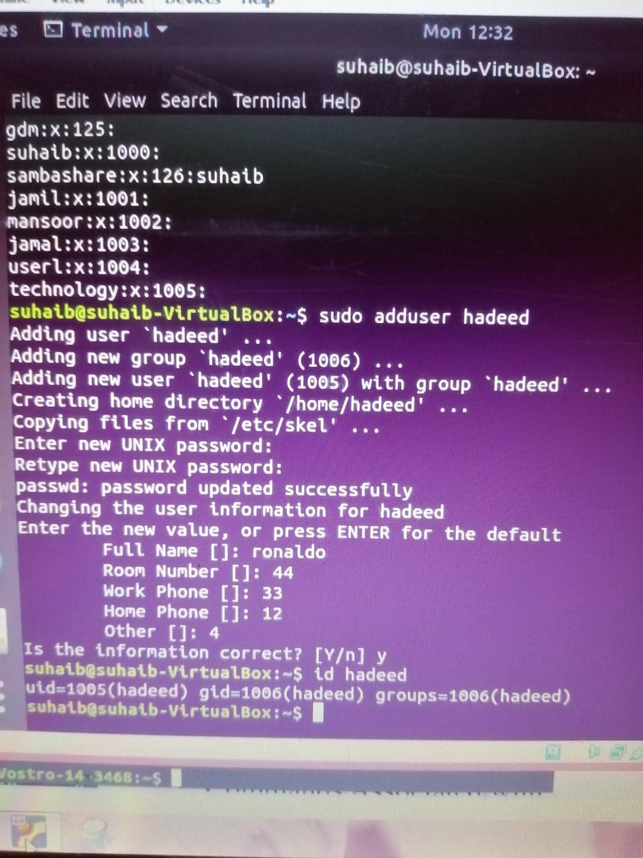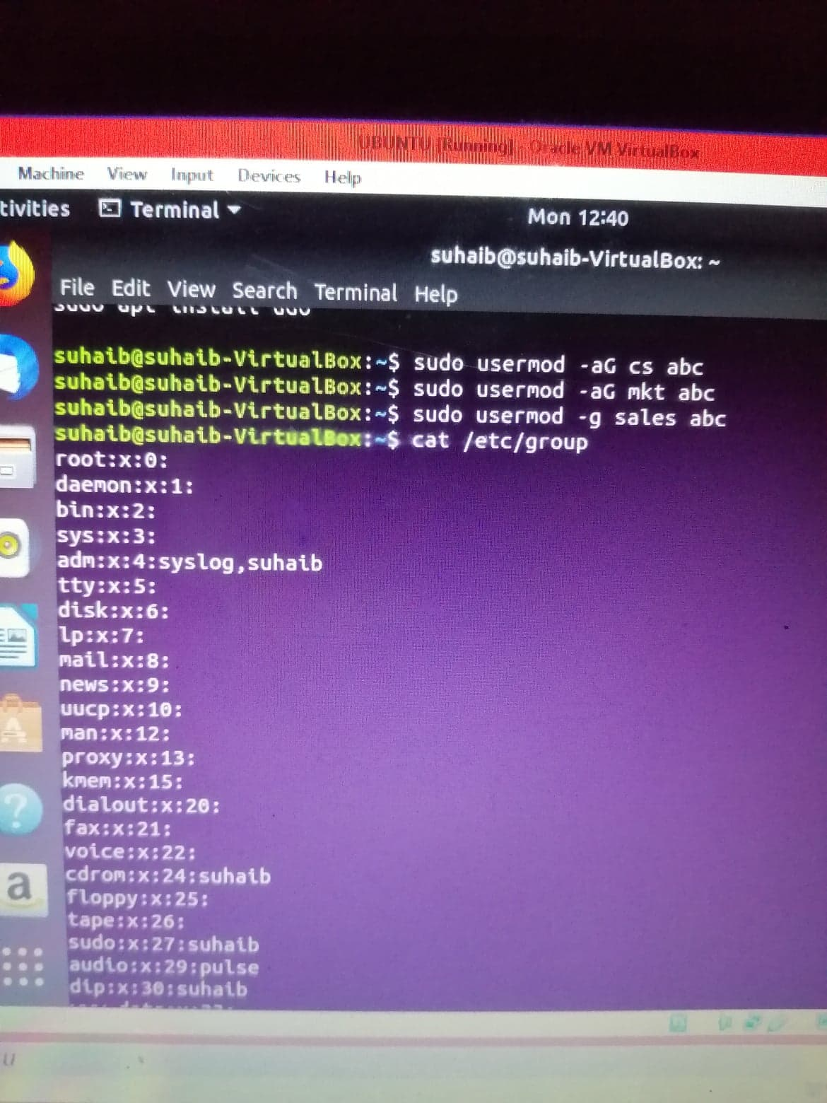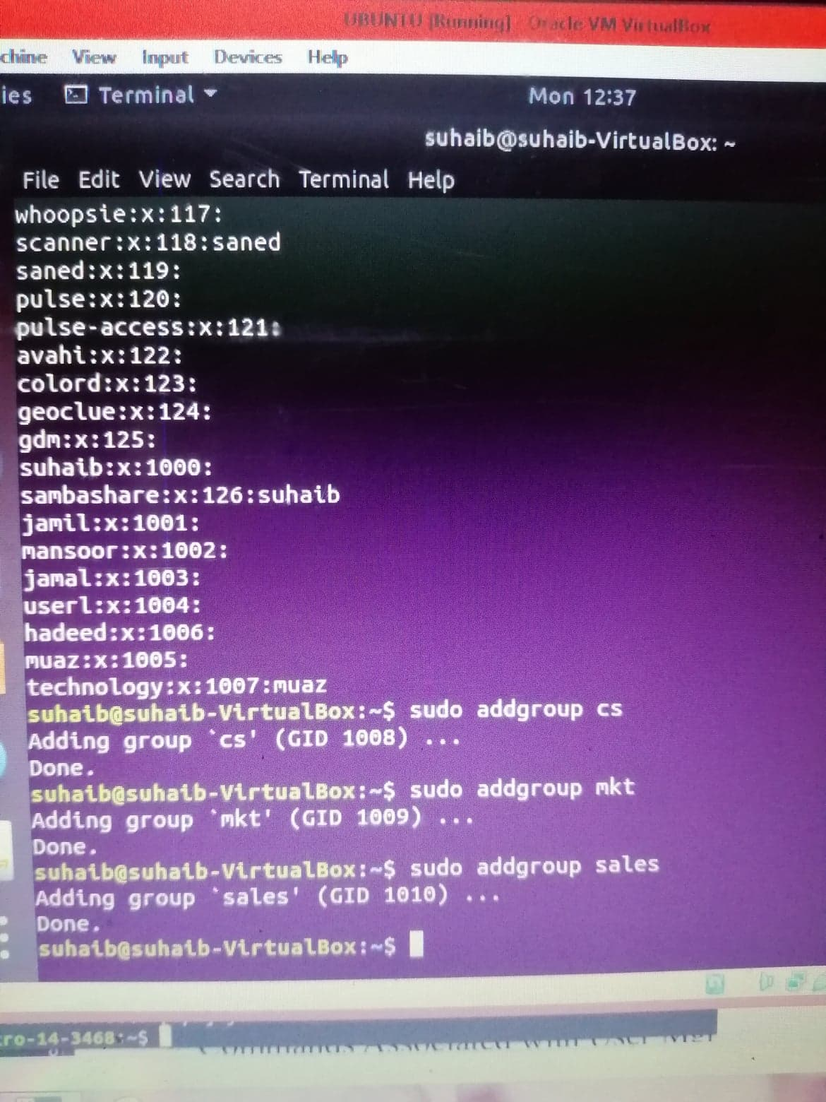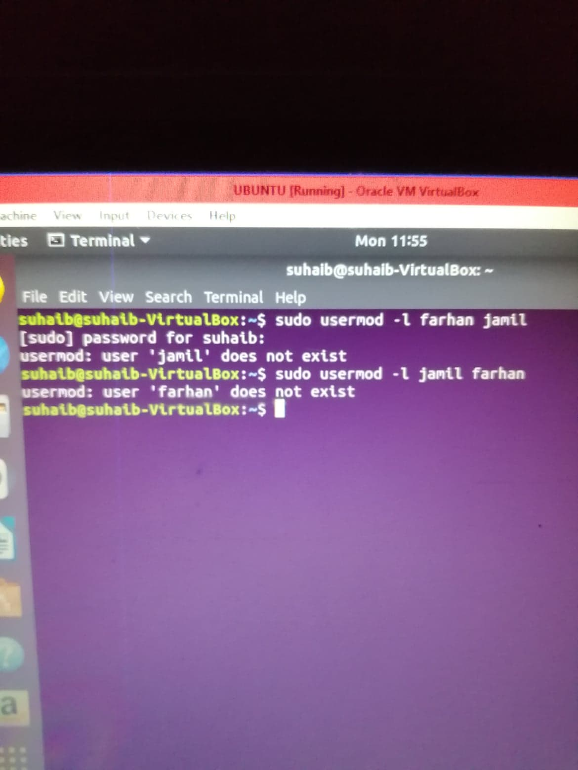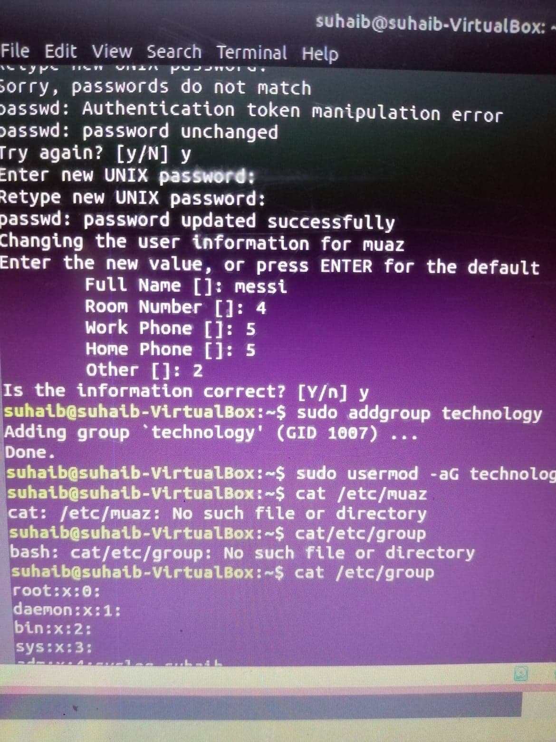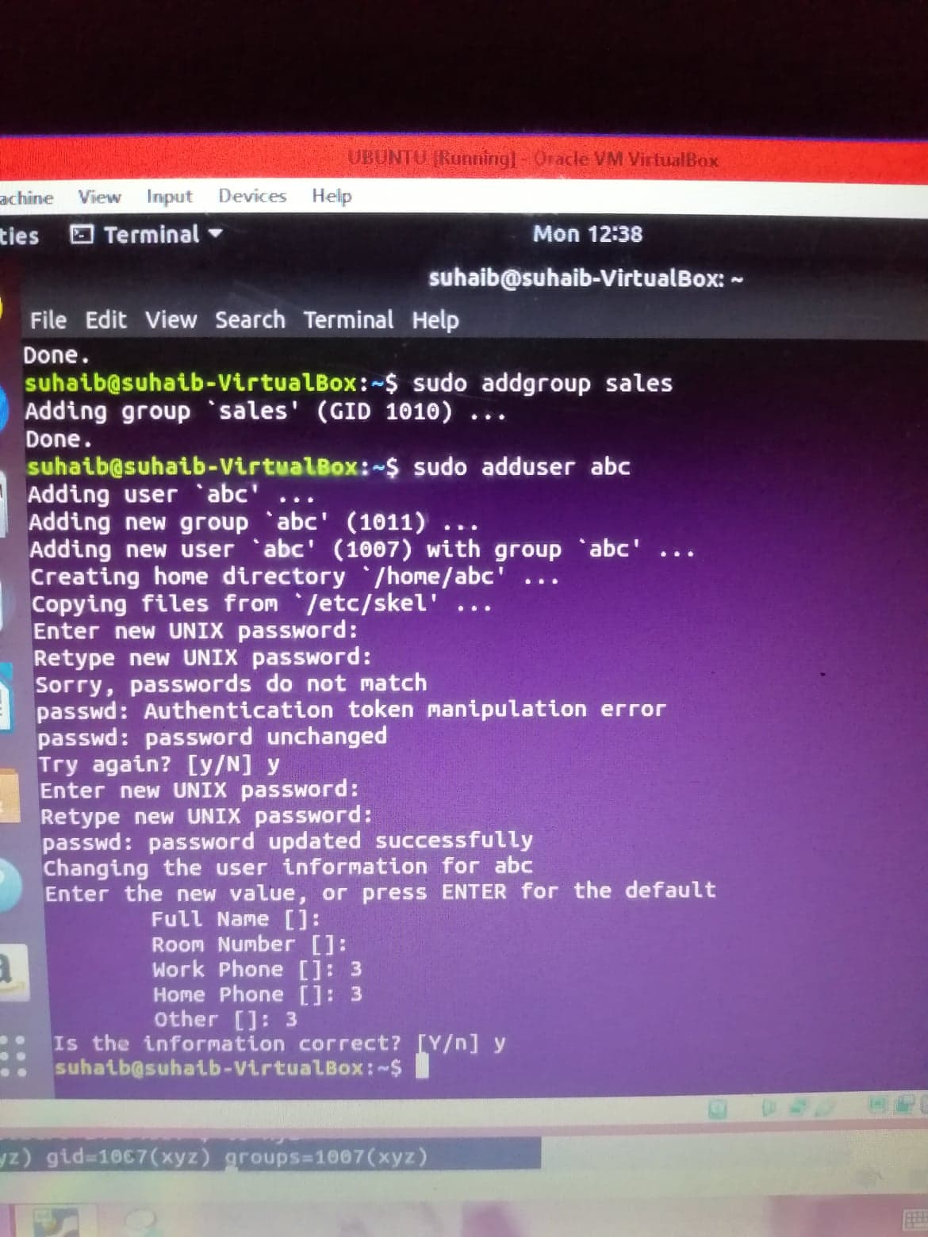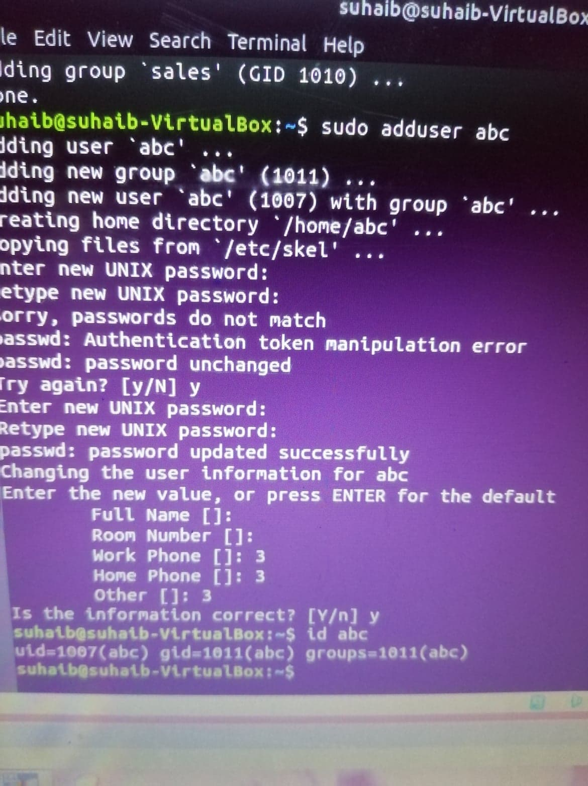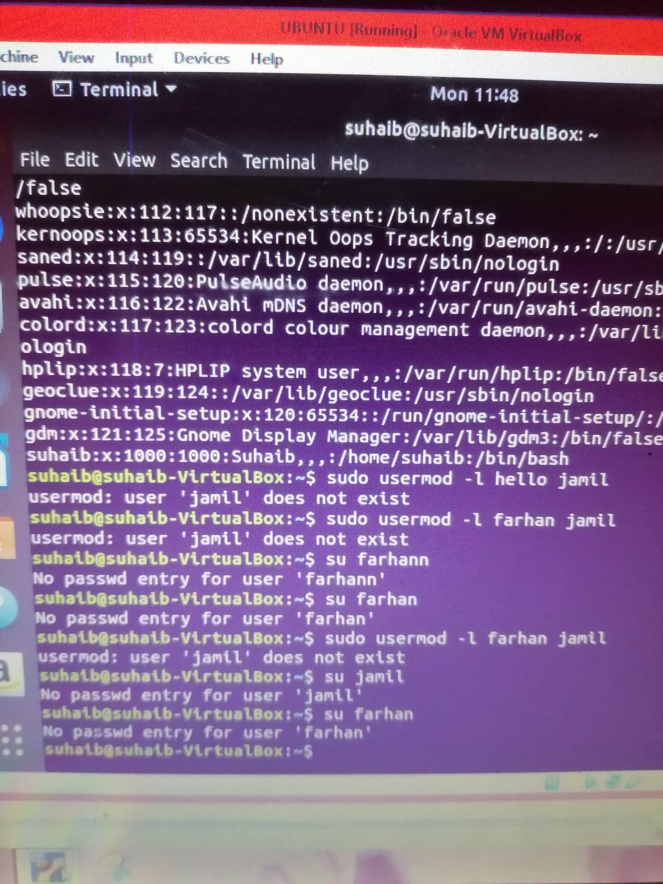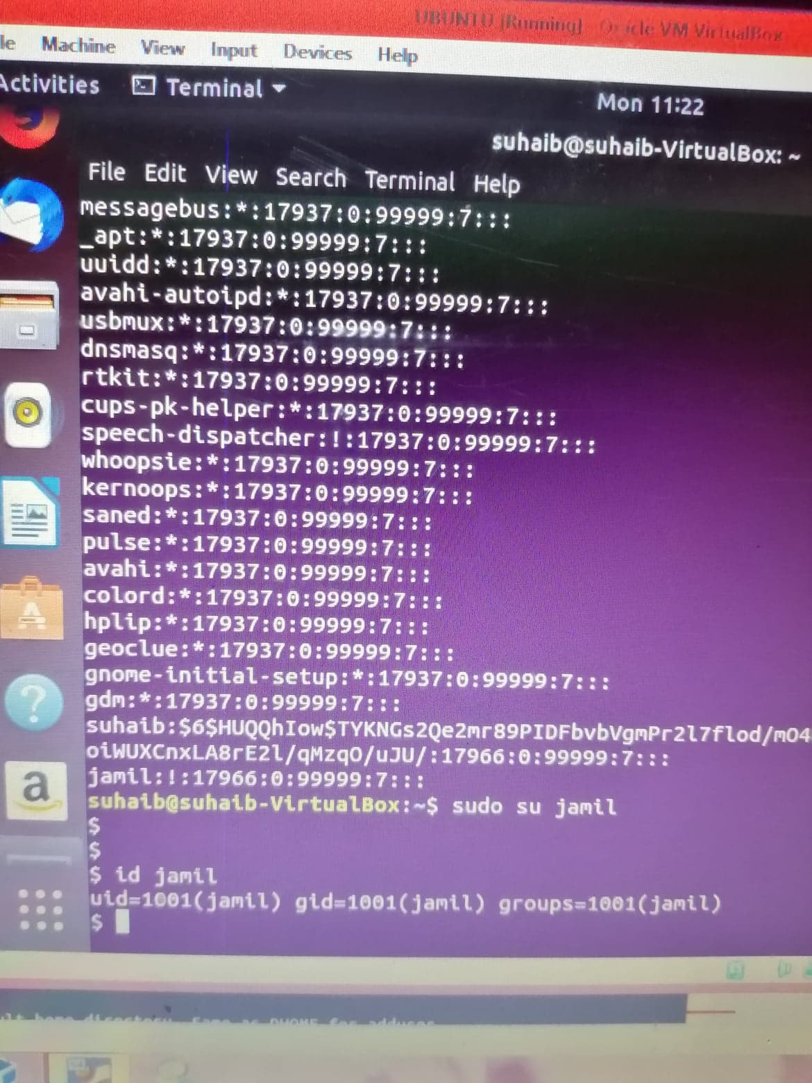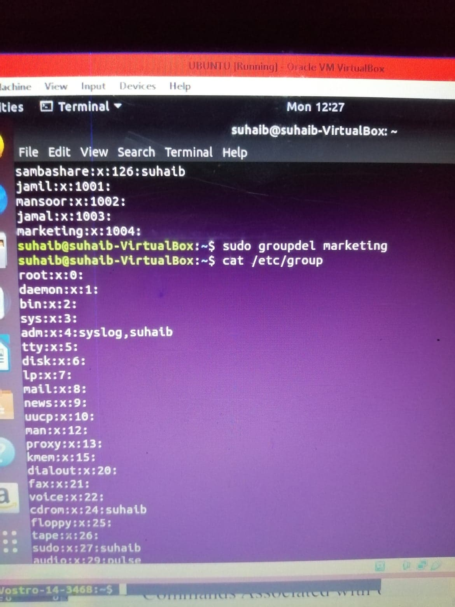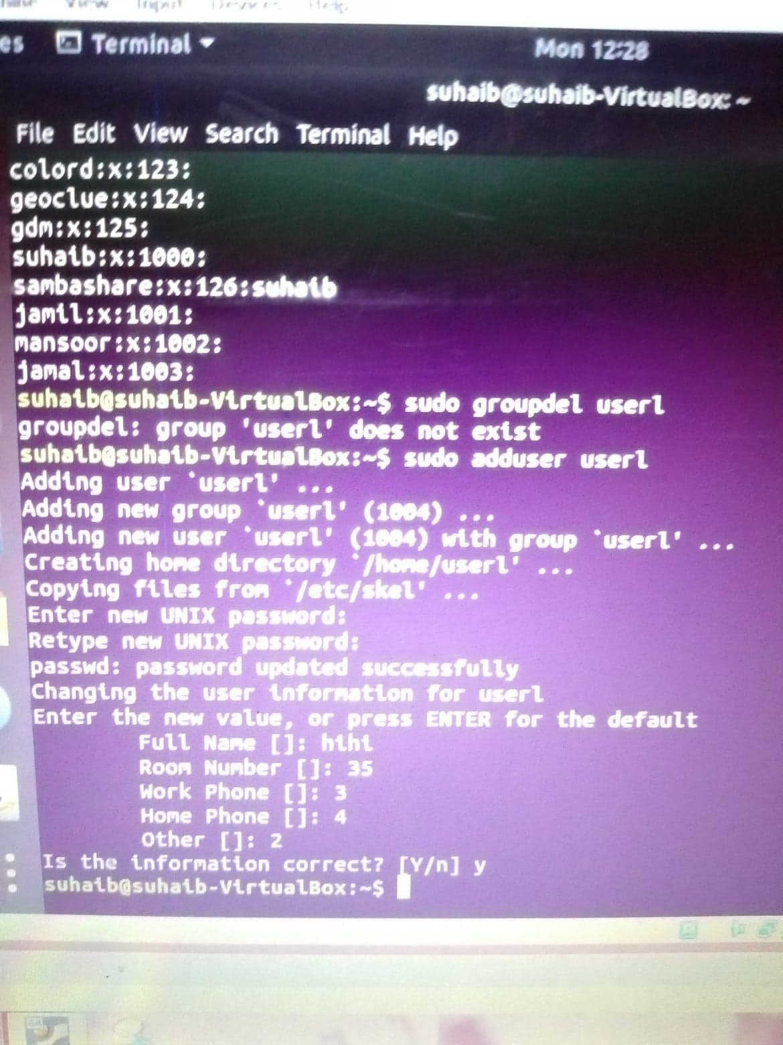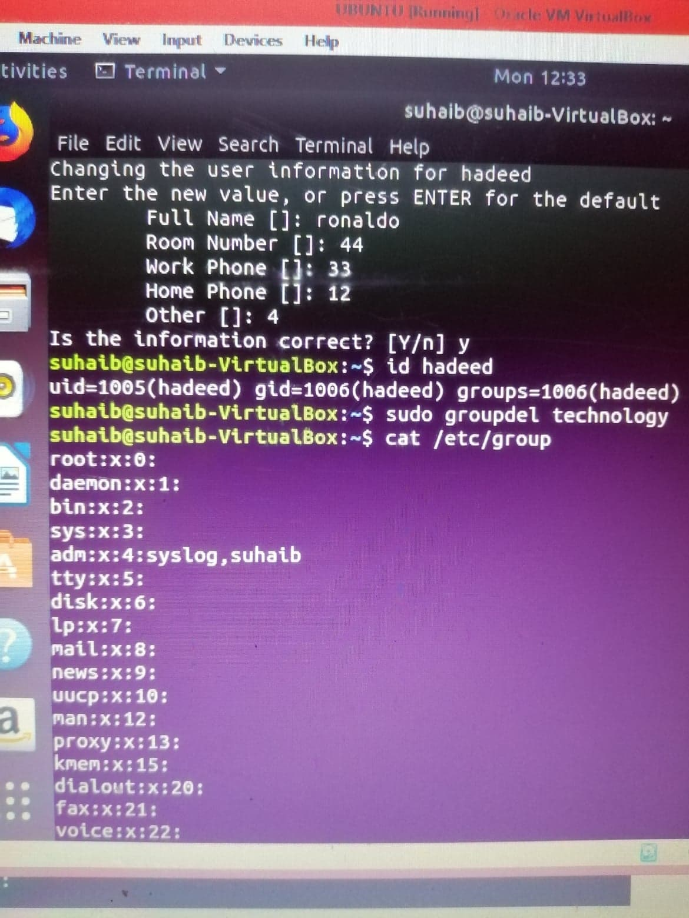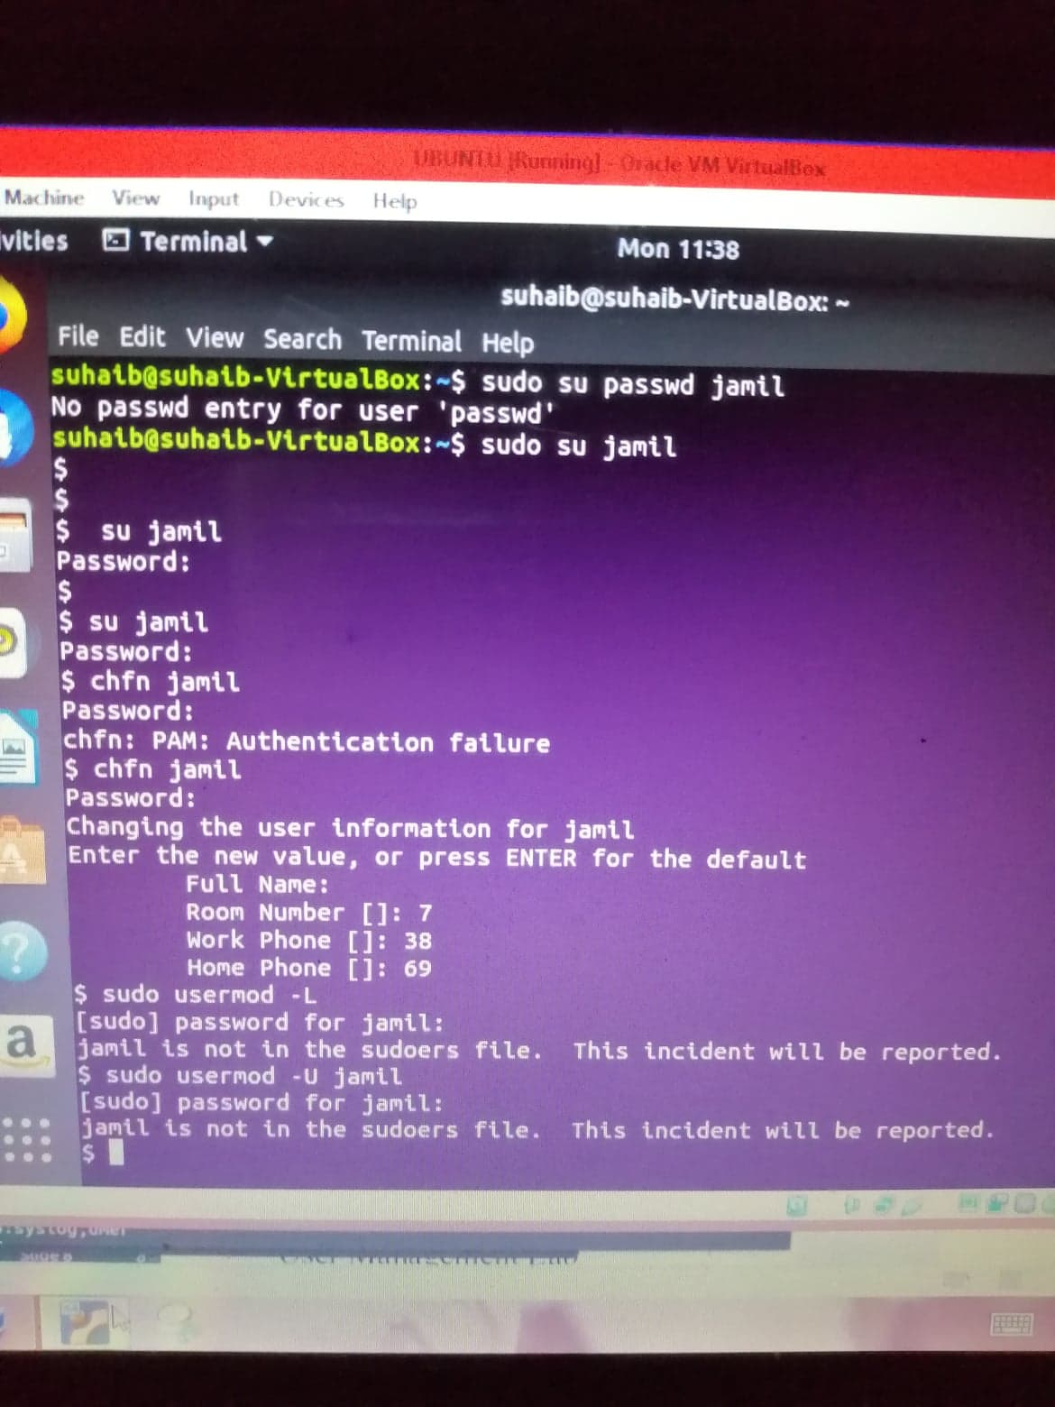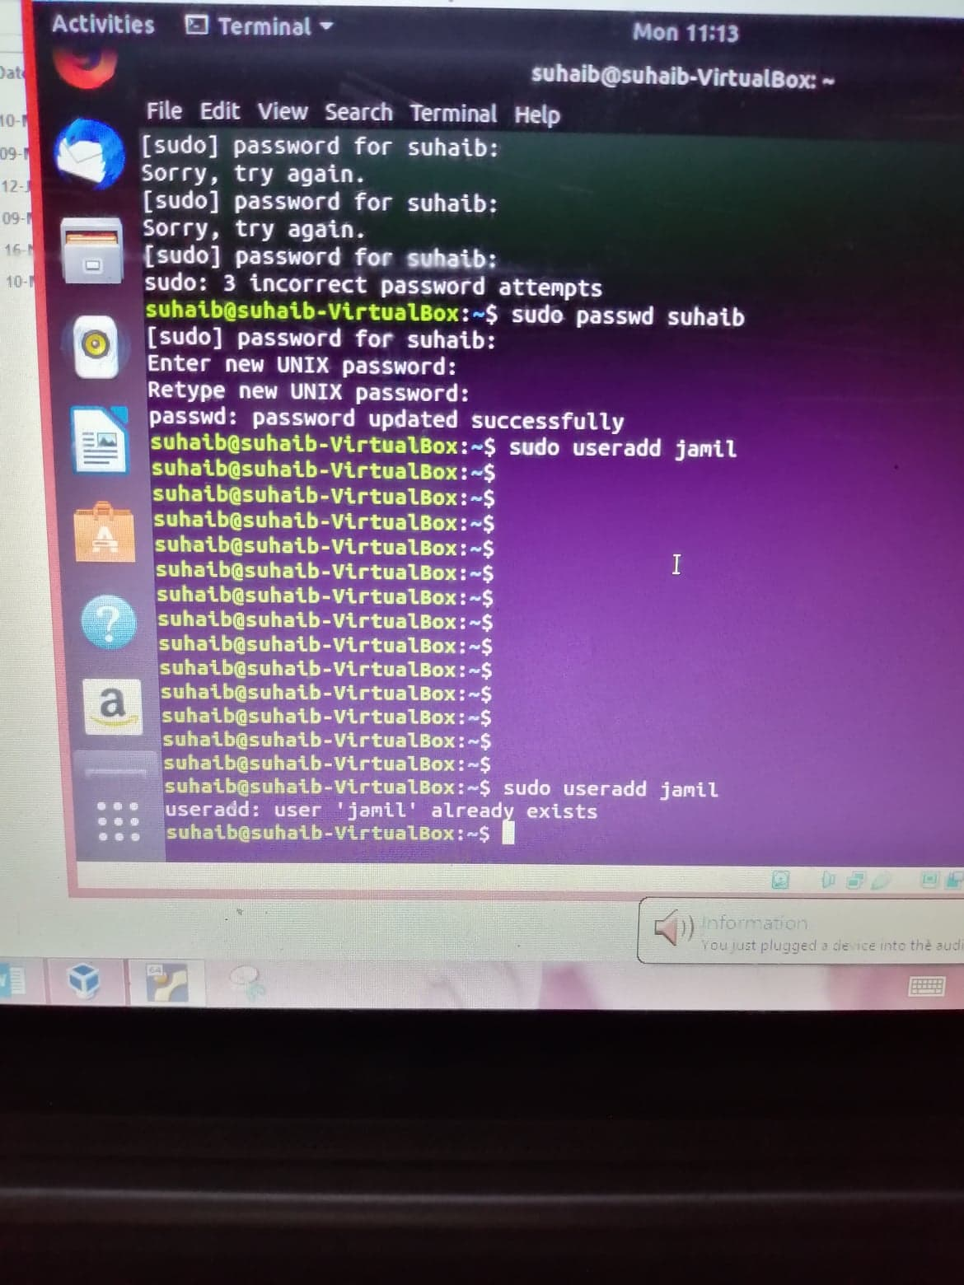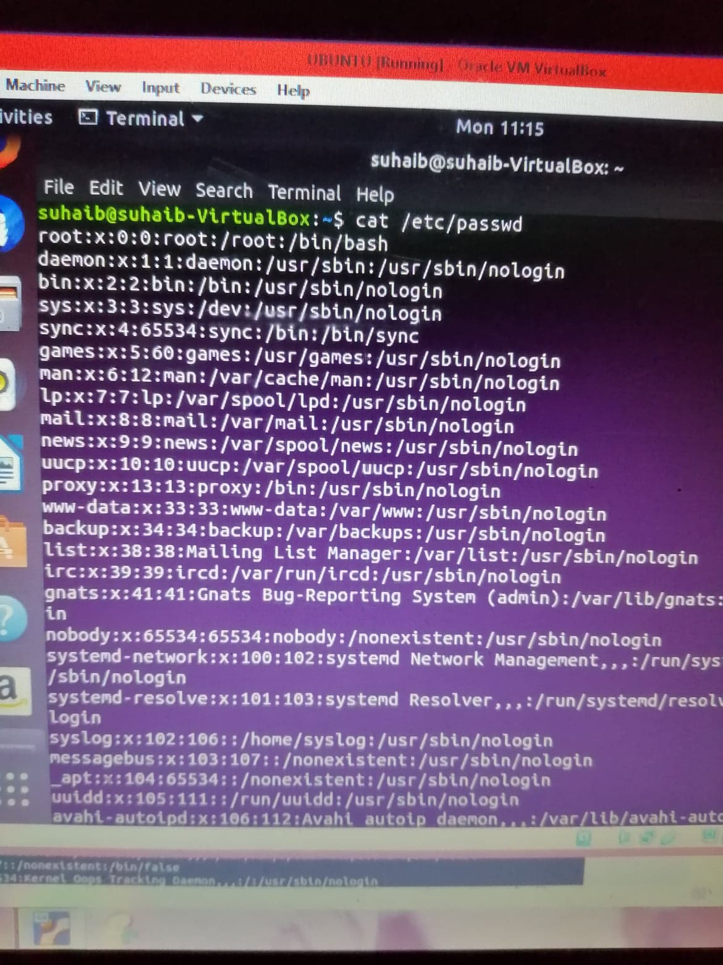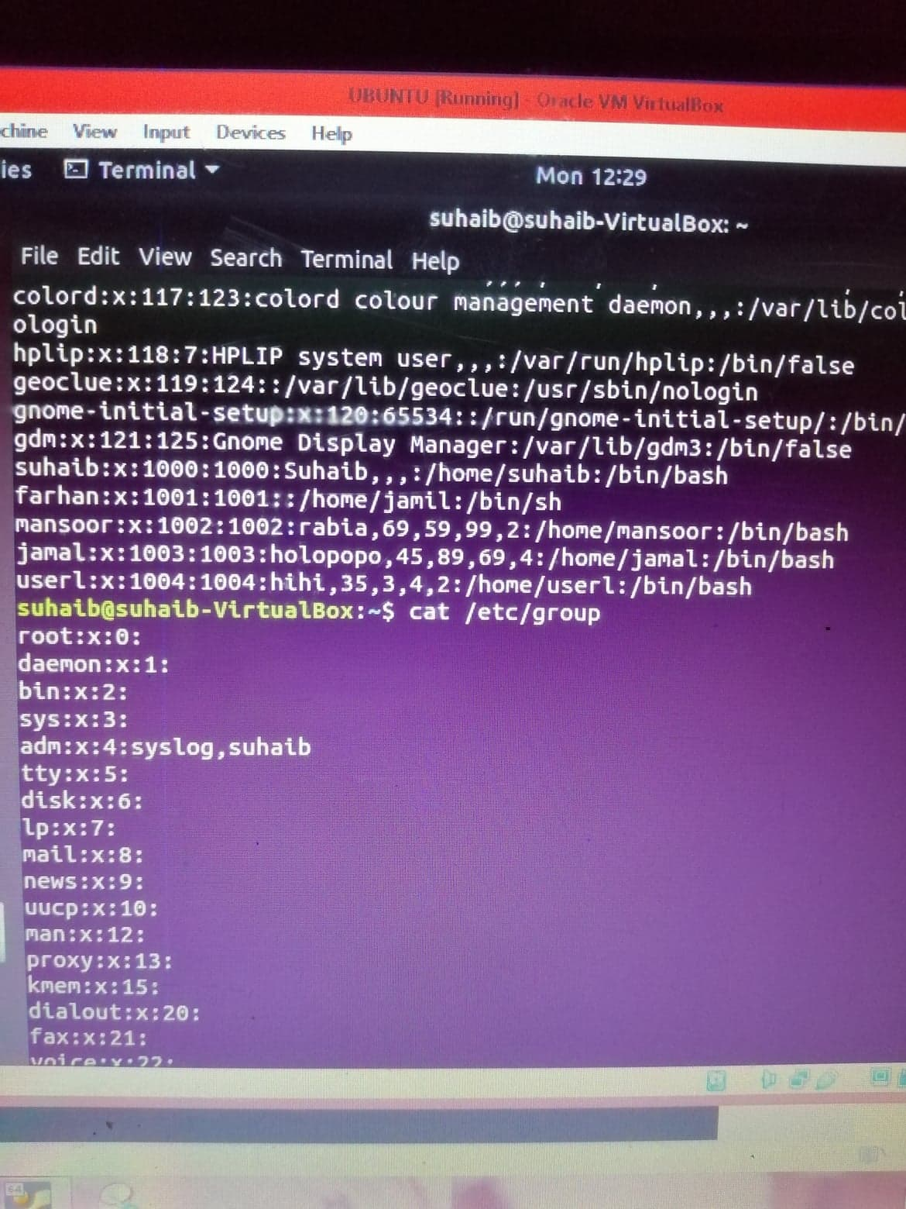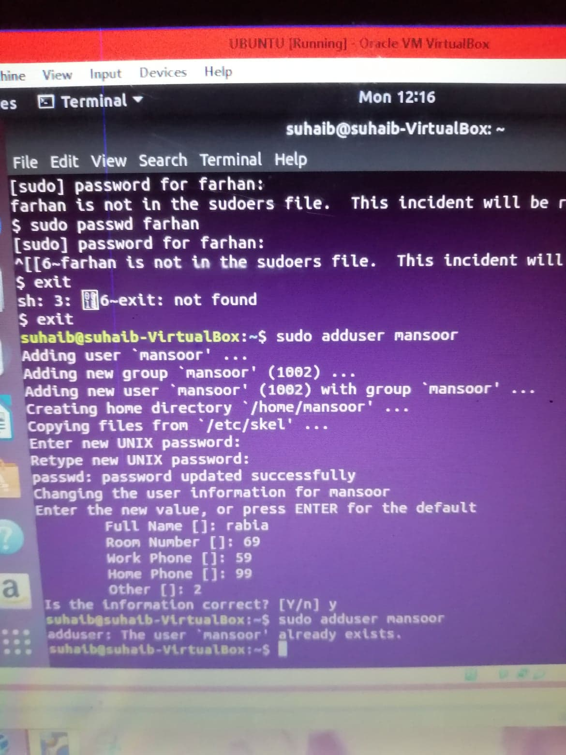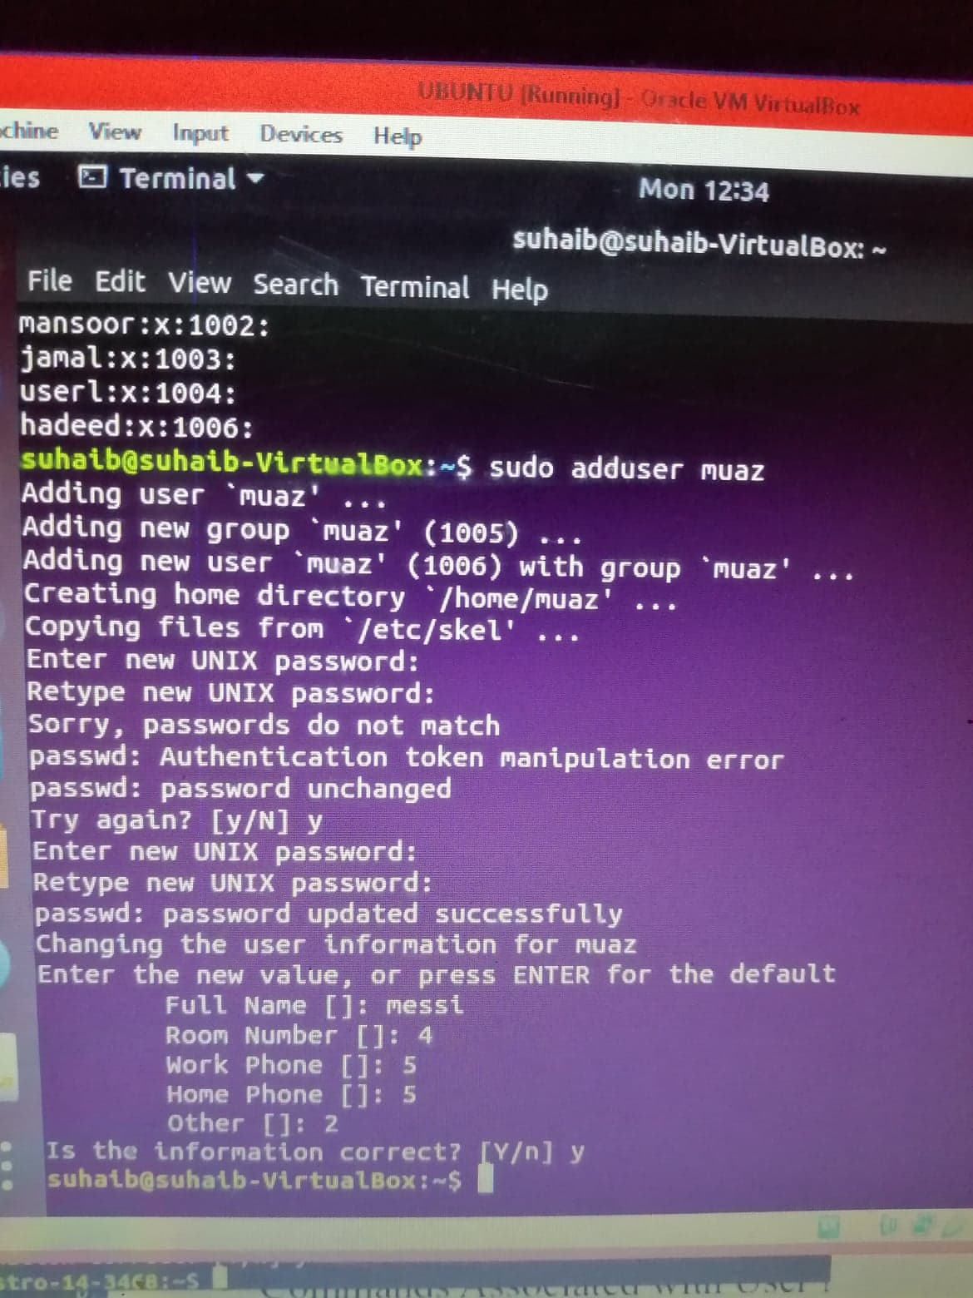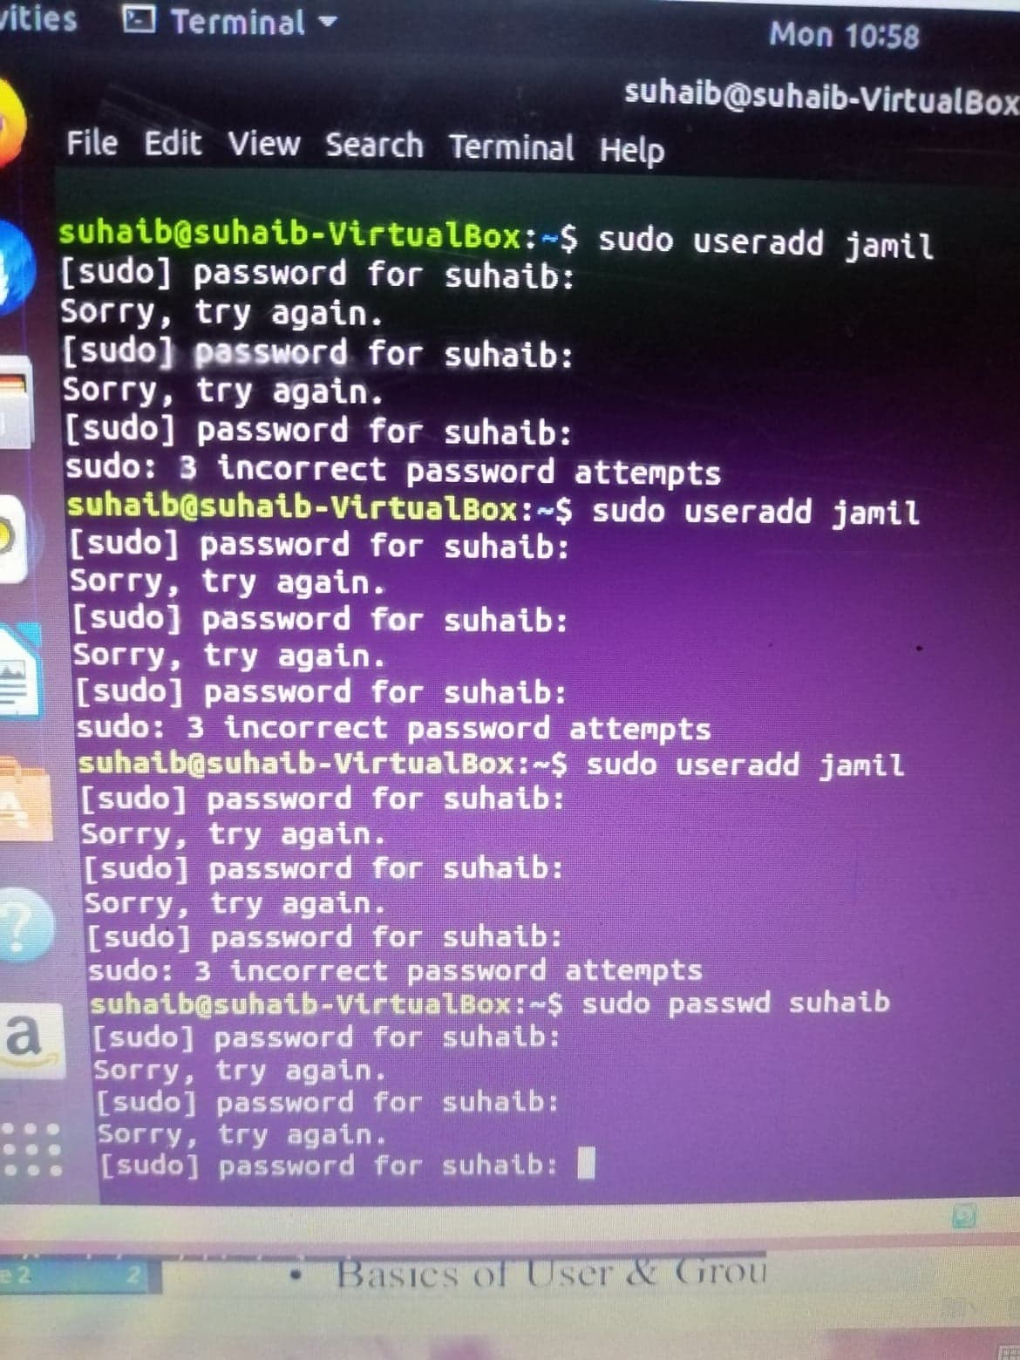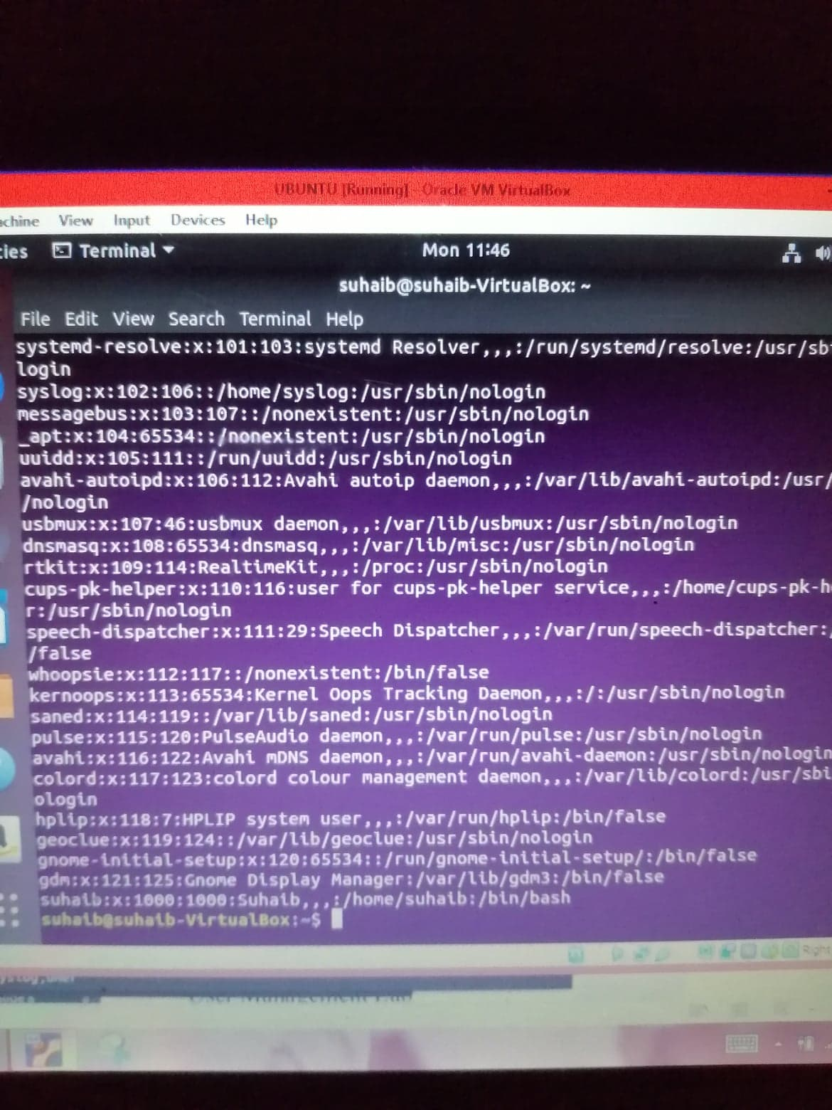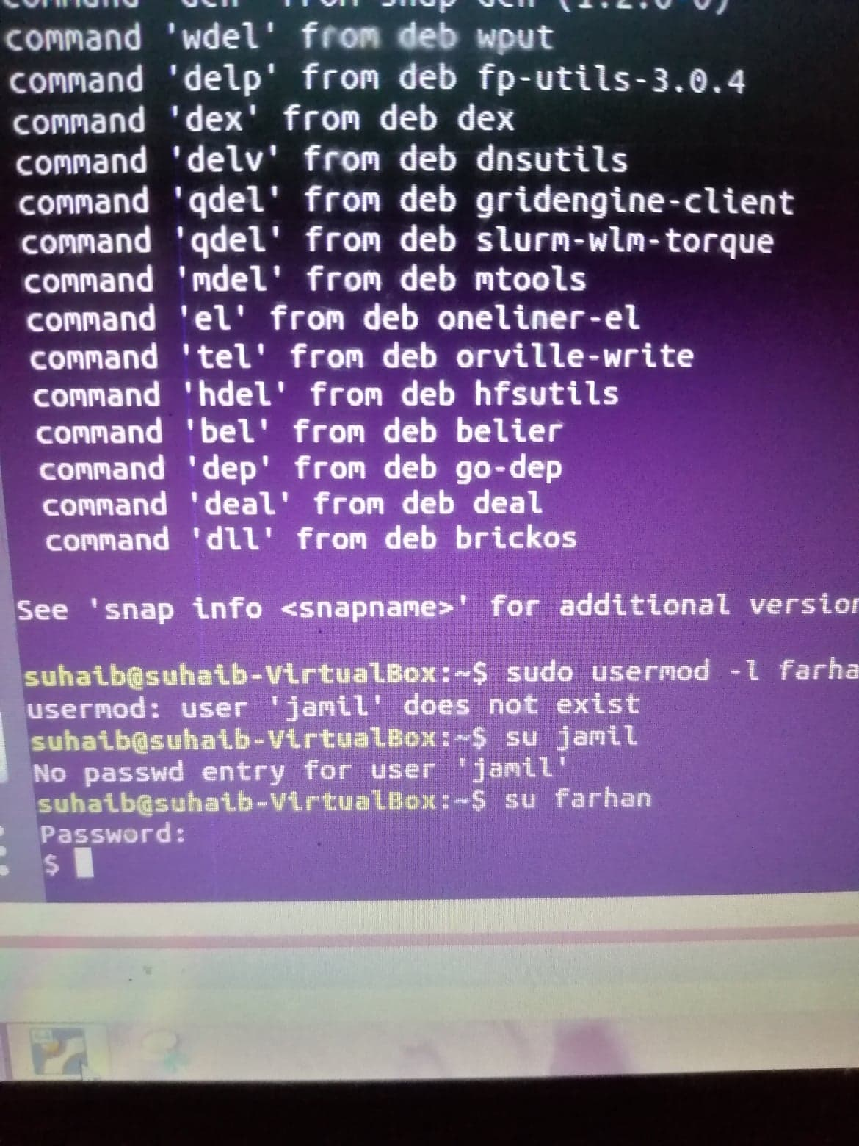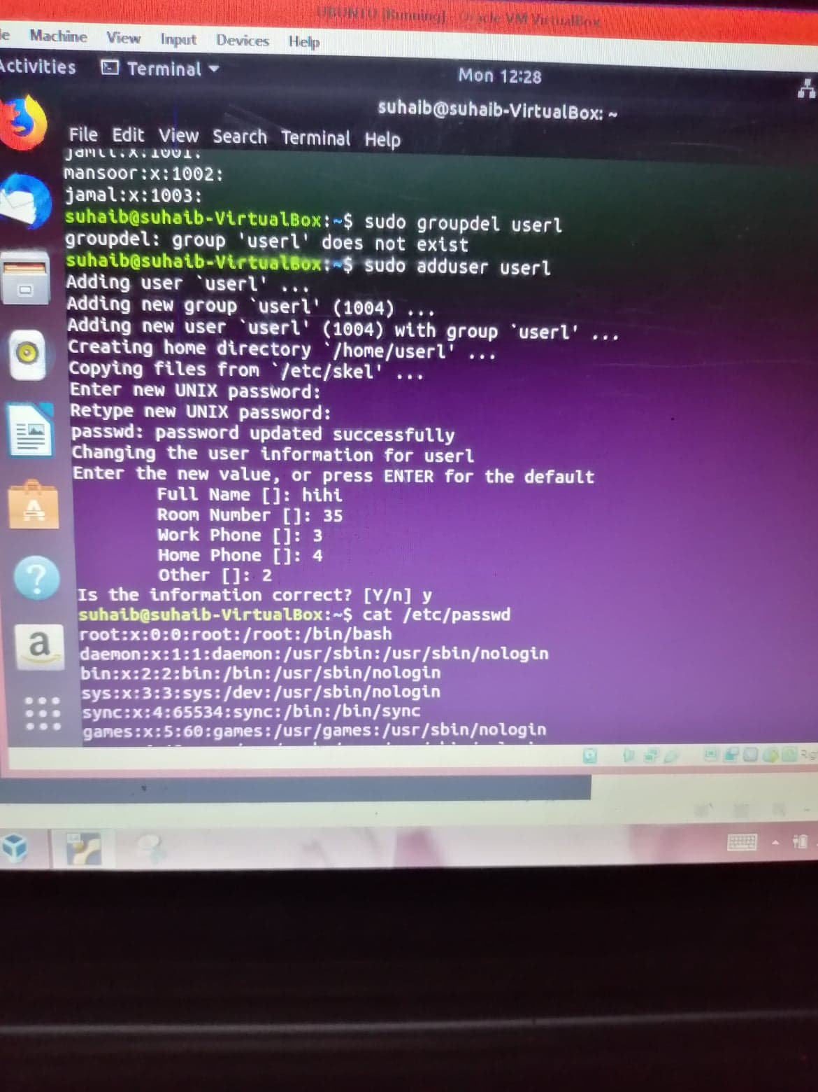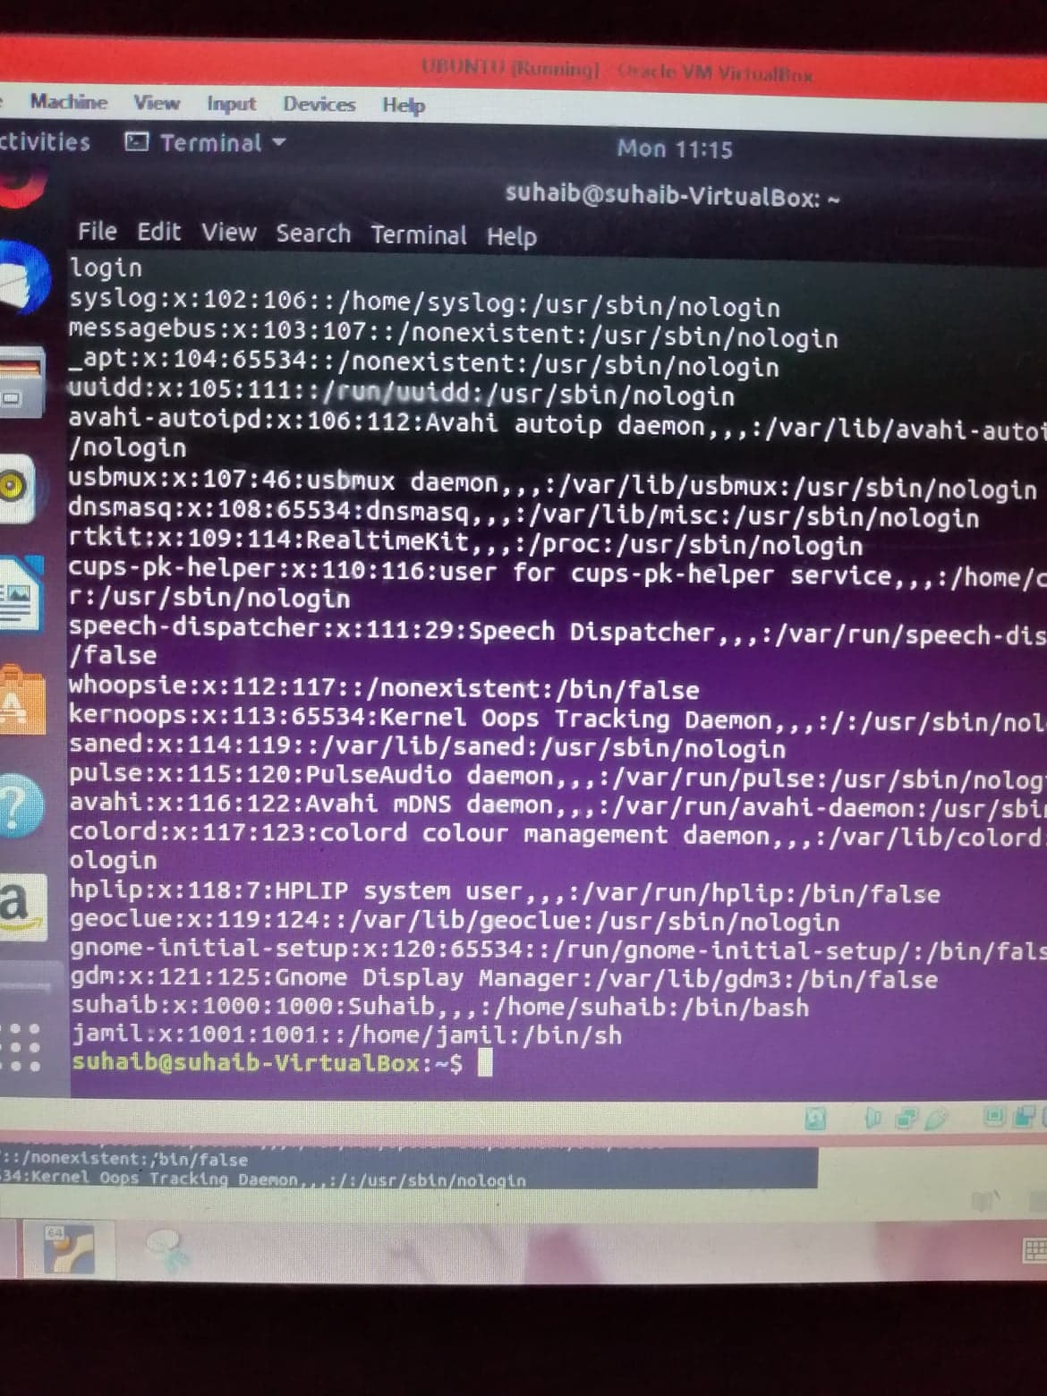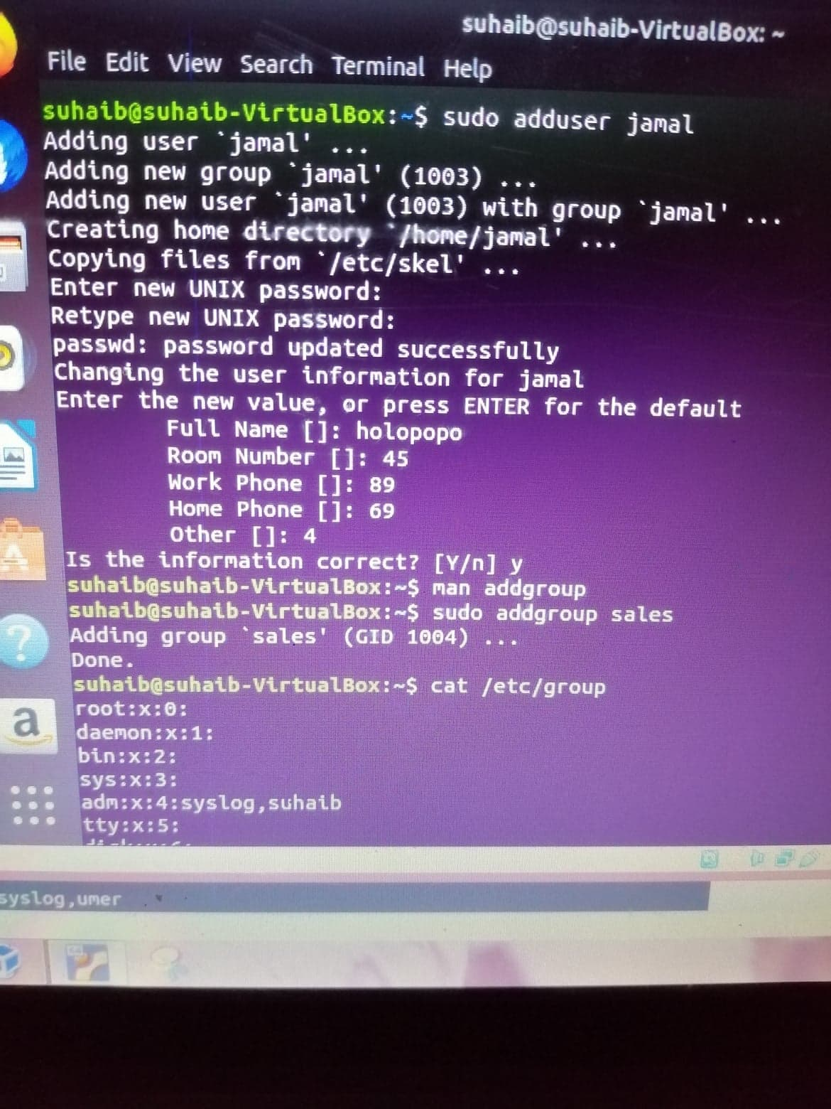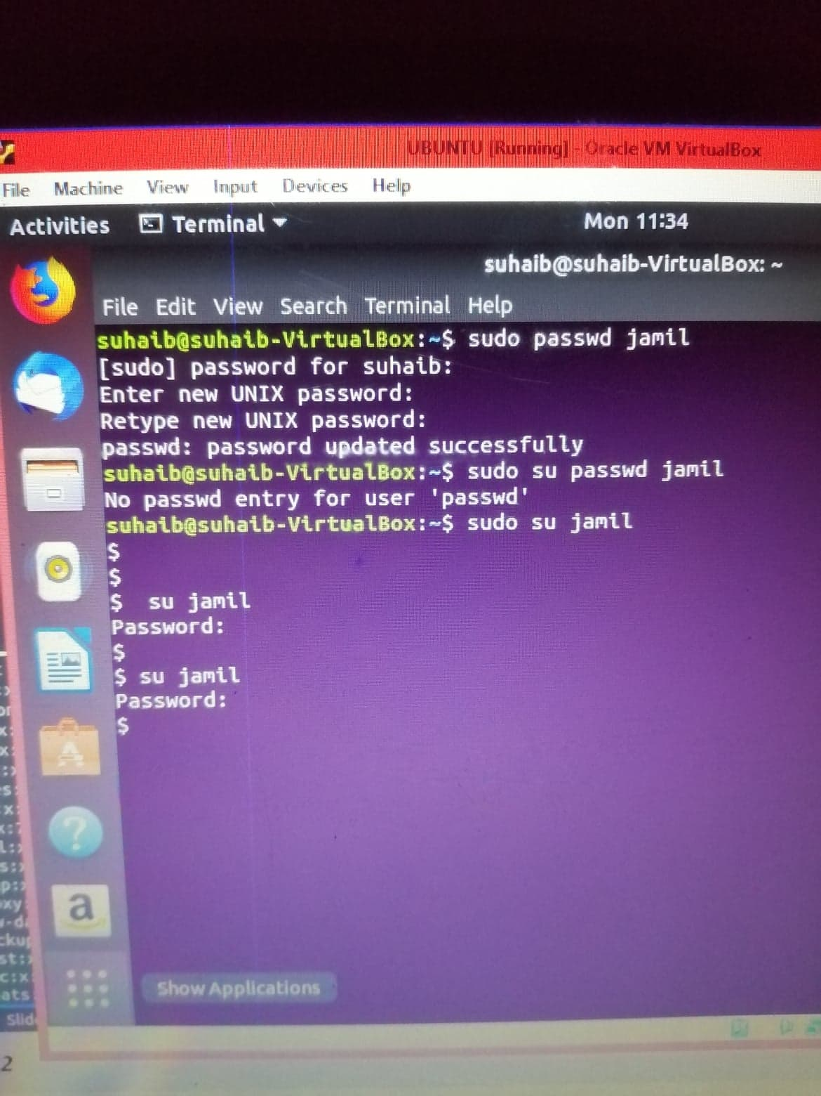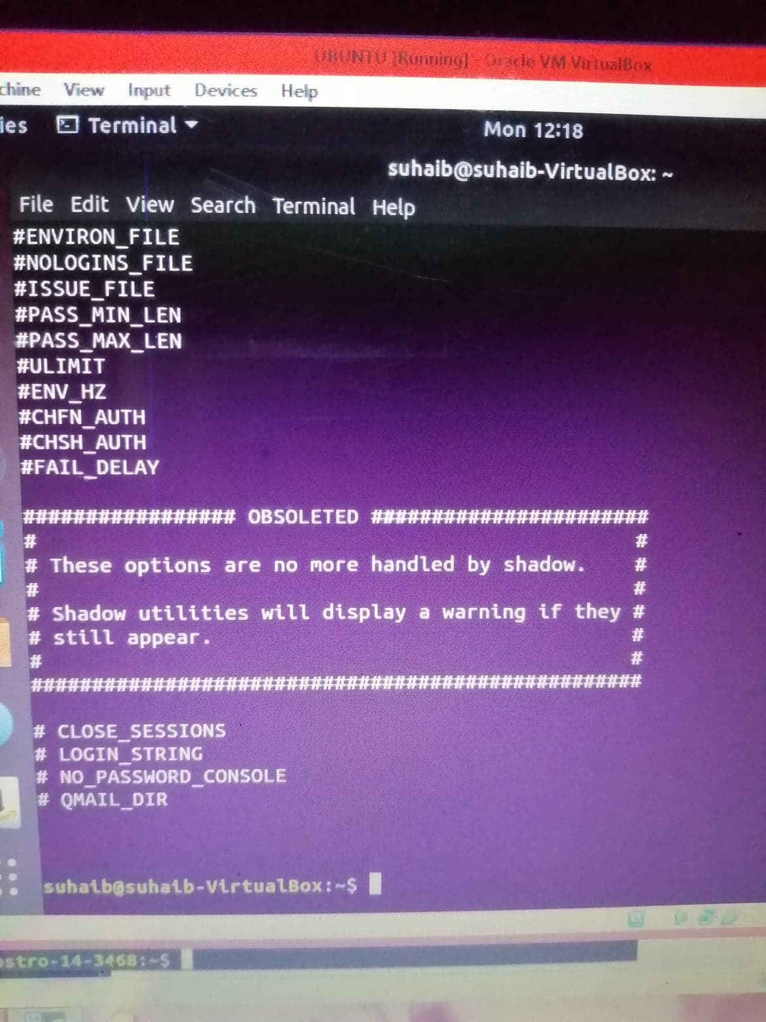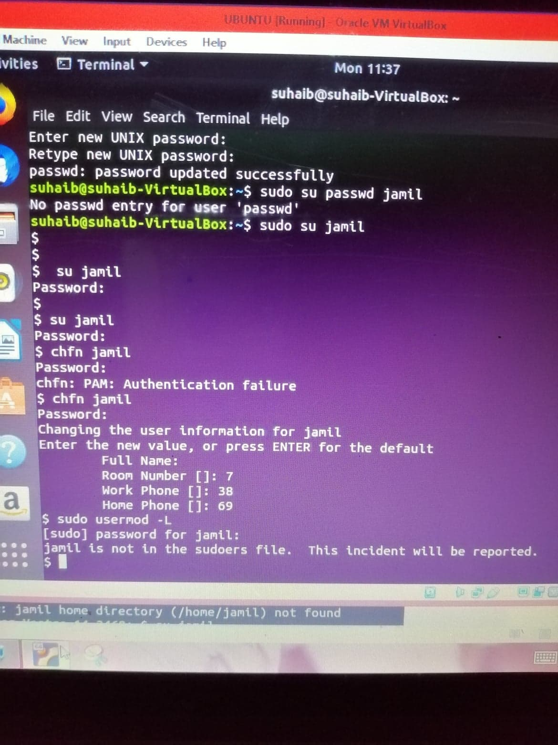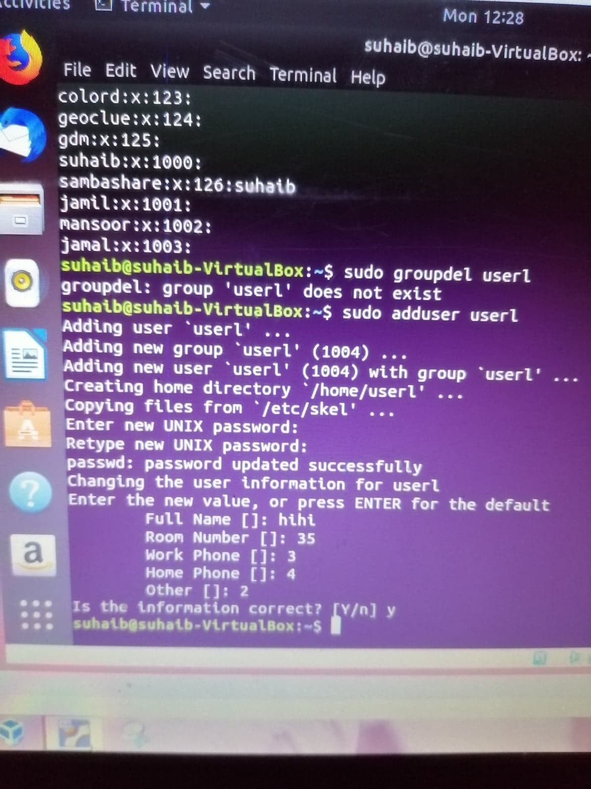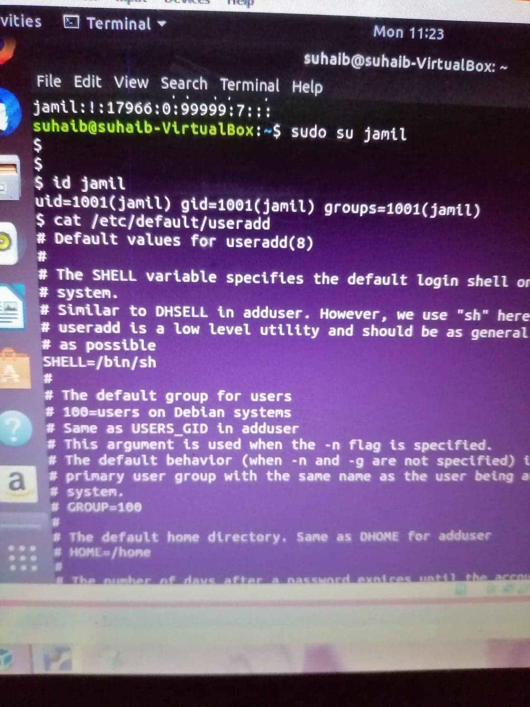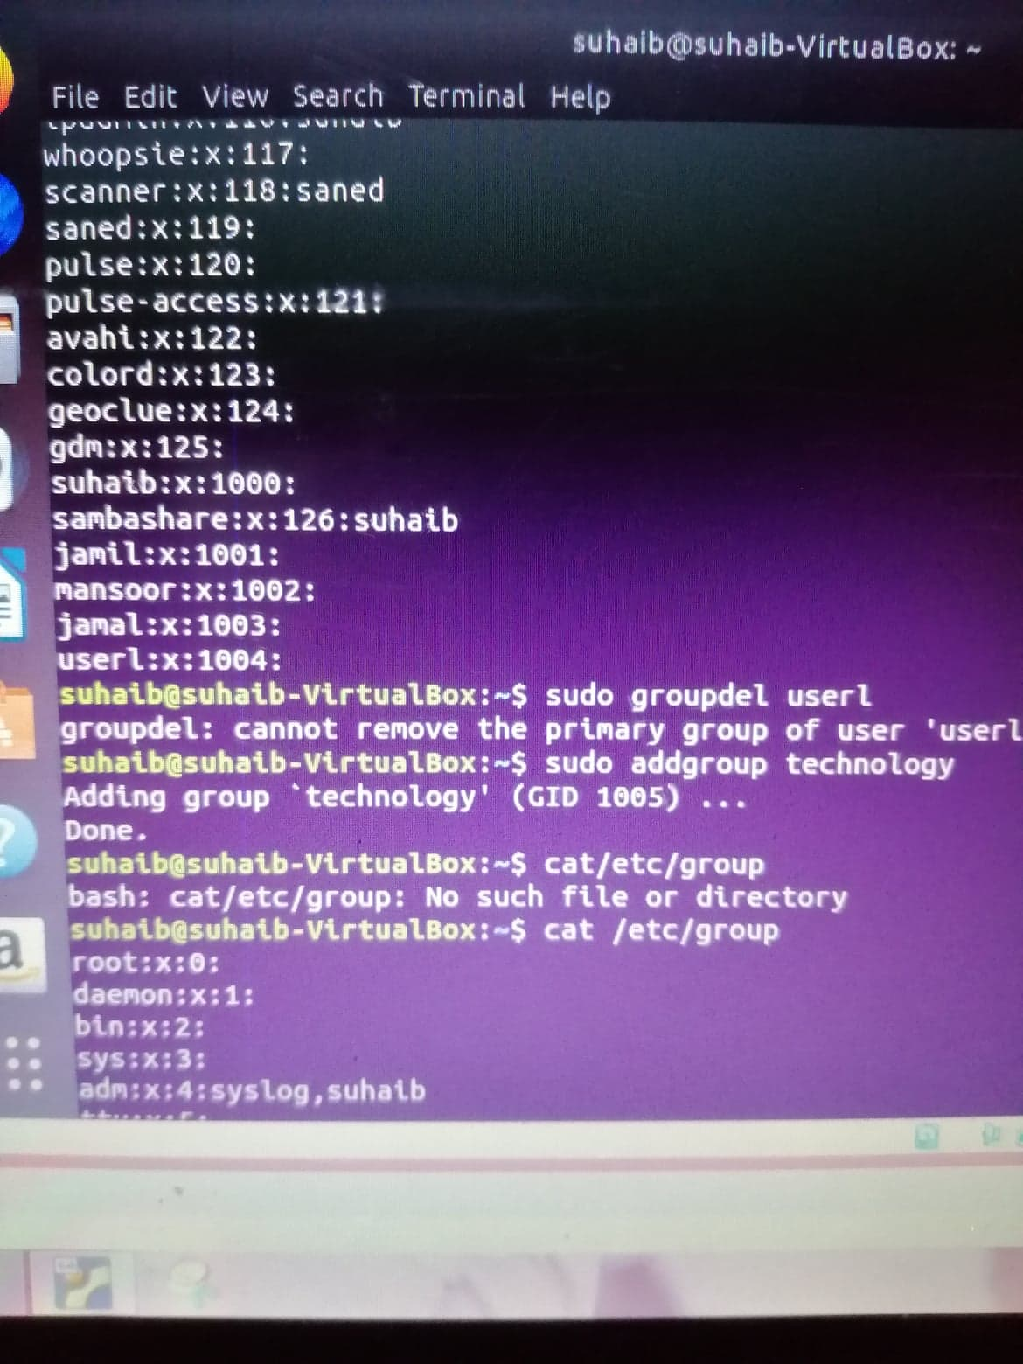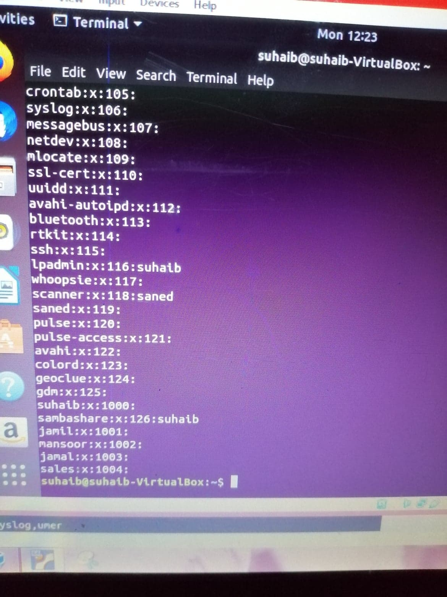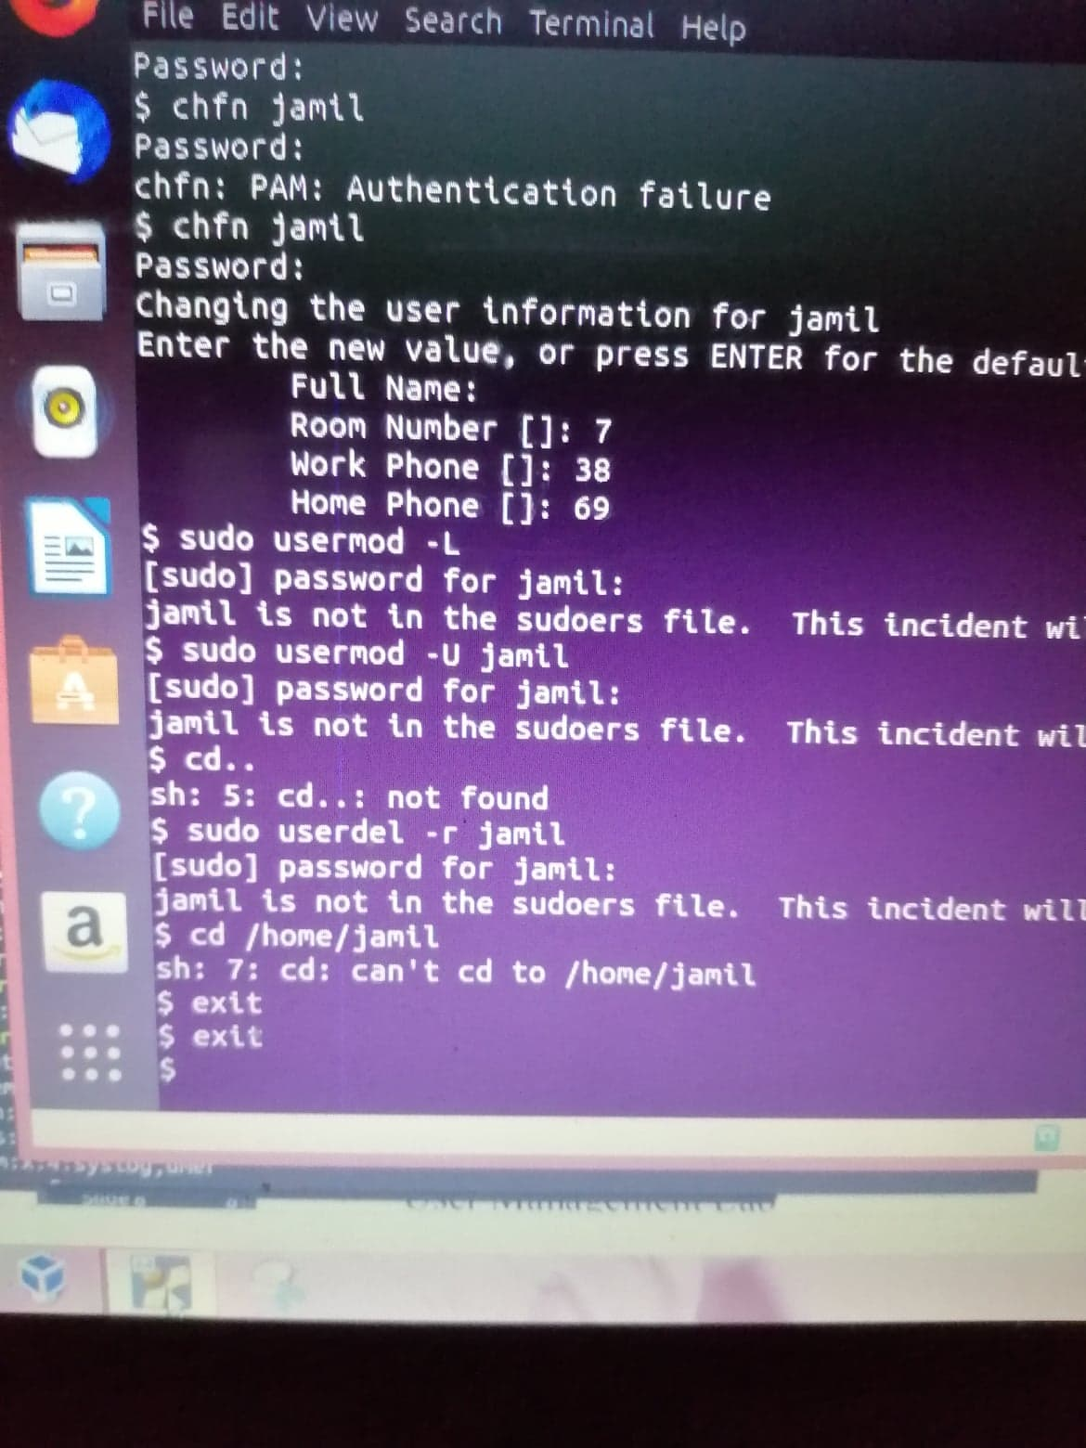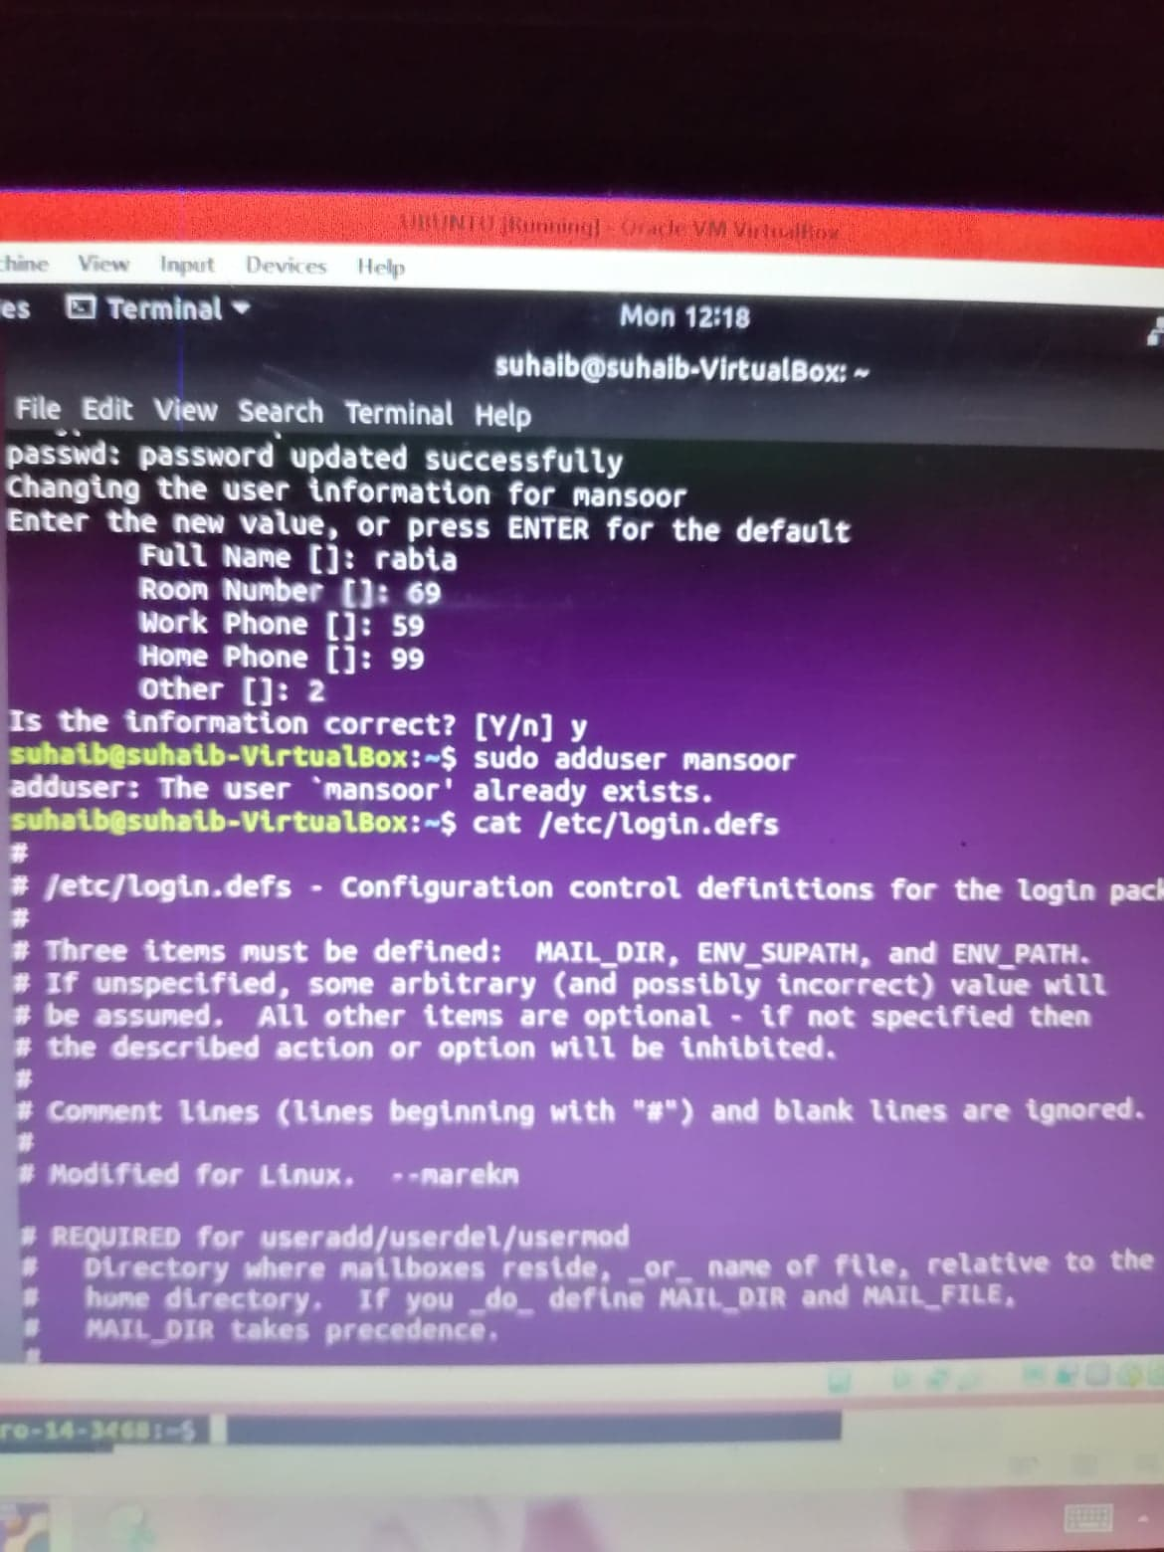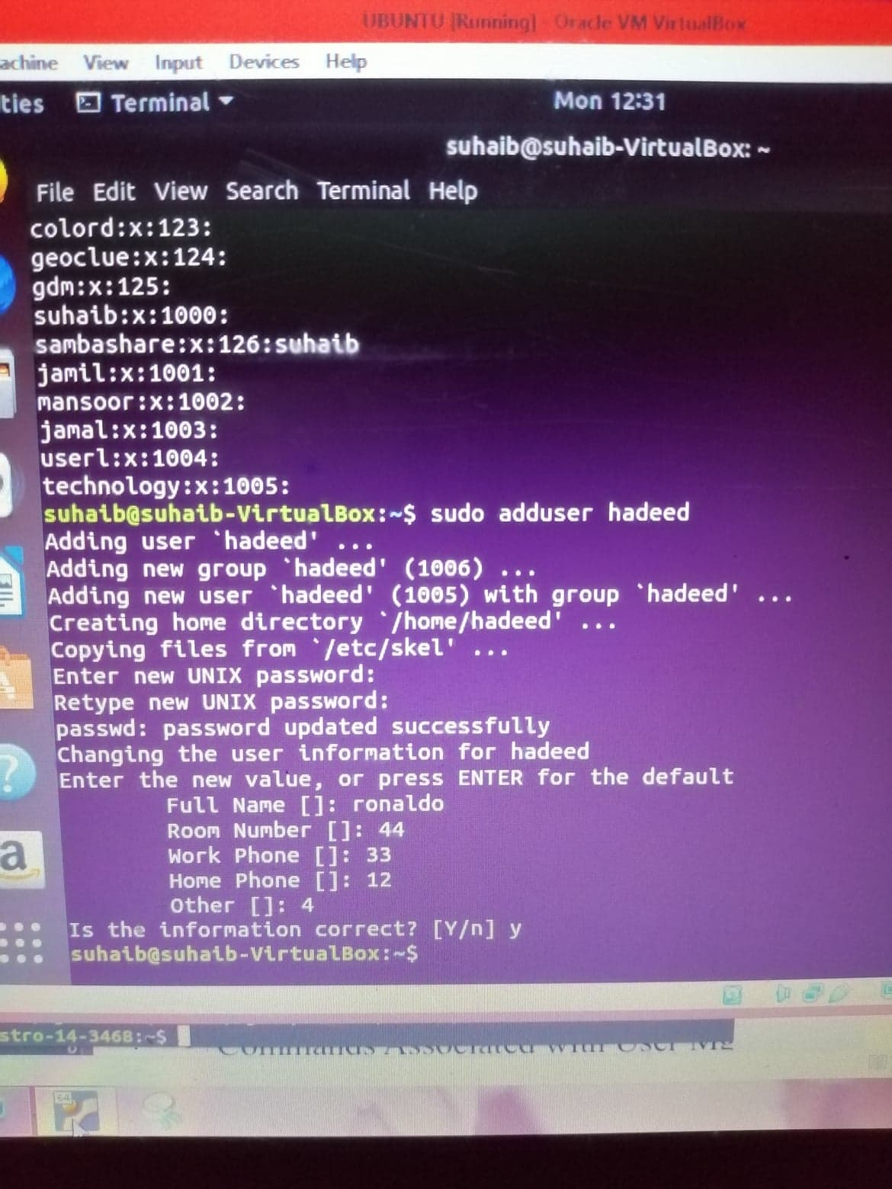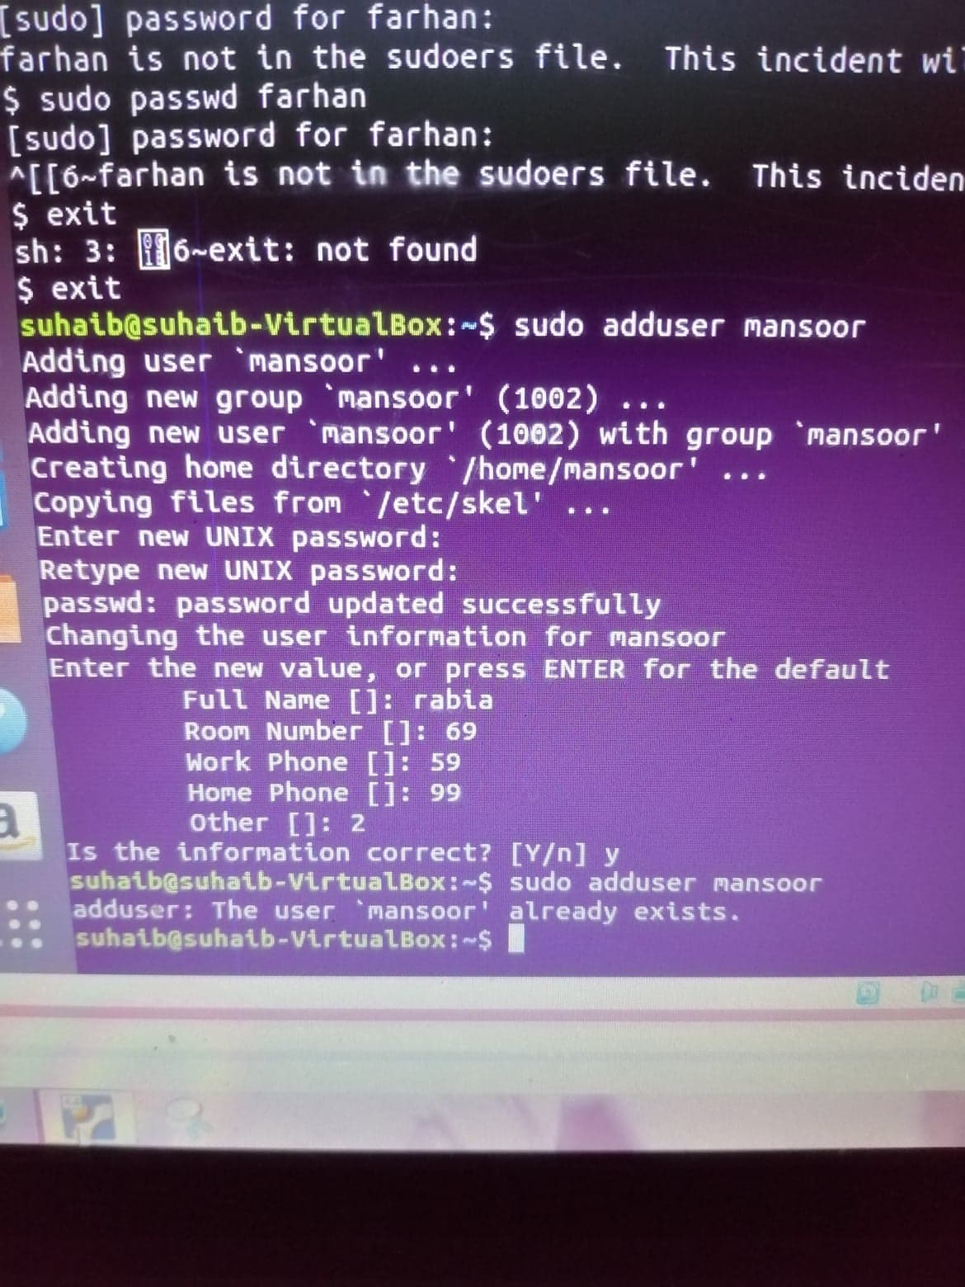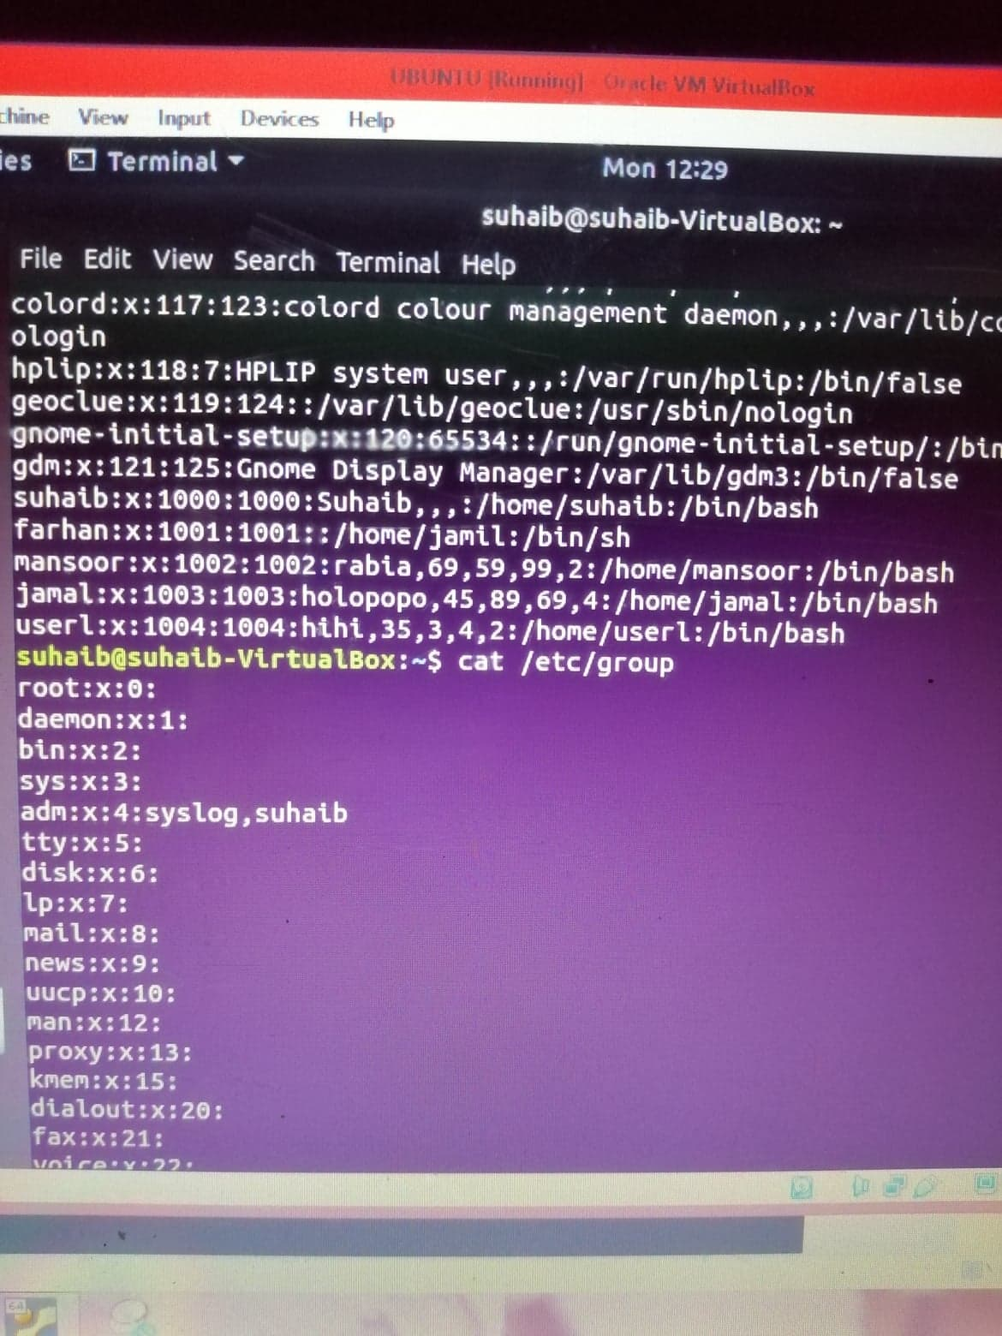

1. *Sudo su*

*adduser tariq*

*adduser khan*

*adduser jamil*

1. *Su khan*

*Mkdir dir1*

*touch dir1/file1*

*ls dir1/file1*

1. *Su tariq*

*Cd tmp/khan/home*

1. *Su khan*

*Cd tmp/dir1*

*Touch tmp/dir1/file1*

*Ls -l tmp/dir1/file1*

1. *Su tariq*

*Cd tmp/dir1*

1. *Sudo su*

*Sudo addgroup sales*

*Sudo addgroup mkt*

*Sudo usermod -g sales tariq*

*Sudo usermod -g sales khan*

*Sudo usermod -aG mkt khan*

*Sudo usermod -aG mkt jamil*

1. *Sudo su khan*

*Chmod 755 /tmp/dir1/file1*

1. *Sudo su tariq*

*Cat /tmp/dir1/file1*

*Ls -l /tmp/dir1/file1*

1. *Sudo su khan*

*Su chown sales file1*

1. *Sudo su khan*

*Gedit tmp/dir1/file1*

1. *Sudo su jamil*

*Gedit tmp/dir1/file1*

1. *Sudo su root*

*Sudo usermod -aG sales jamil*

*Sudo su jamil*

*Cat /tmp/dir1/file1*

***TASK 6***

1. *Chmod 740*
2. ***a.*** *rwx-r------ permission to file/directory courses*

***b.*** *users = rwx permission to file/directory courses*

***c****. rwx------ permission to ~ directory*

***d.*** *user group and others eliminate read write access of file sample*

***e.****all eliminate read write access to file sample*

***g.*** *group access gets equal to user’s access*

***h****. others and group access of same gets = ---*

***i****. rwxrwxrw- for file/directory named lab*

***j.*** *rwxr-x—x for file/directory named lab*

1. *mkdir course sample personal*

*chmod 740 sample*

*ls -l*

*chmod o+r sample*

*ls -l*

1. *main folder not accessible*